**Section 1**

* Launch Captivate and click on new responsive project

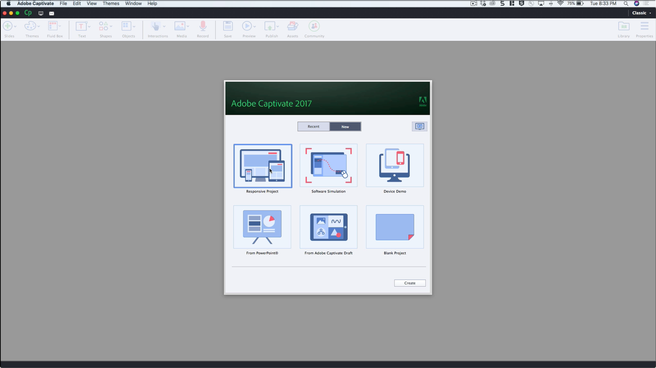

* Save the project to your desktop and name it “Cooking 101”

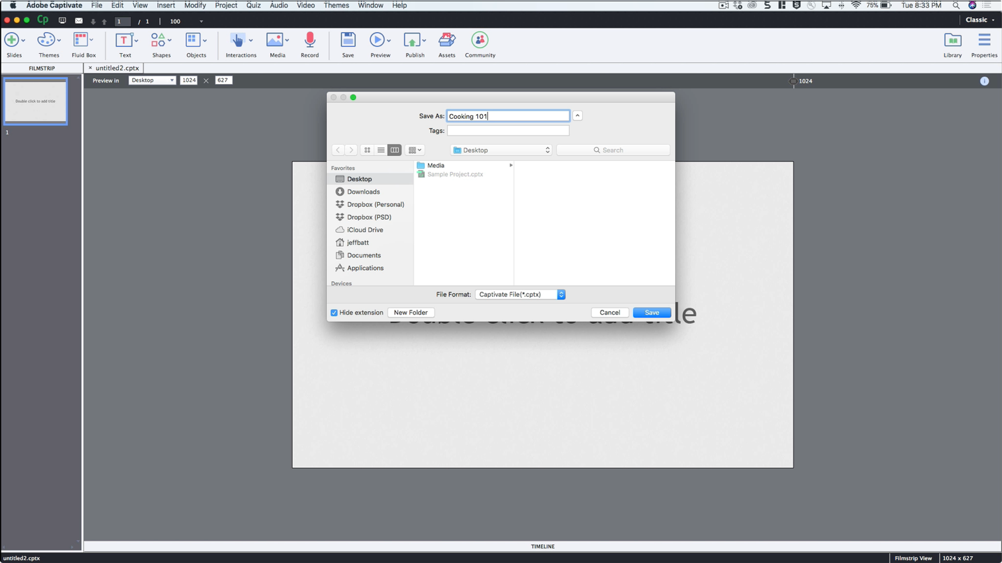

* Click on the first page and go into the properties of that page and give the first page a name “Welcome Page”

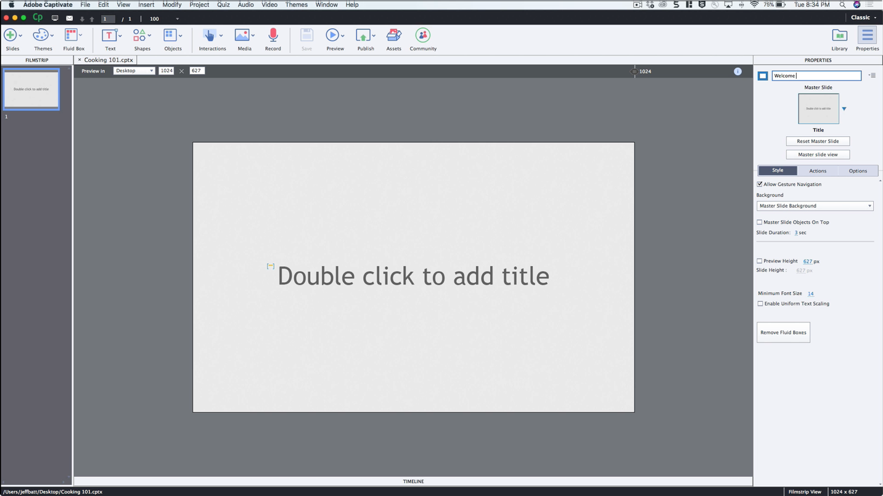

* Click on Slides on the top left and then create a new blank slide.

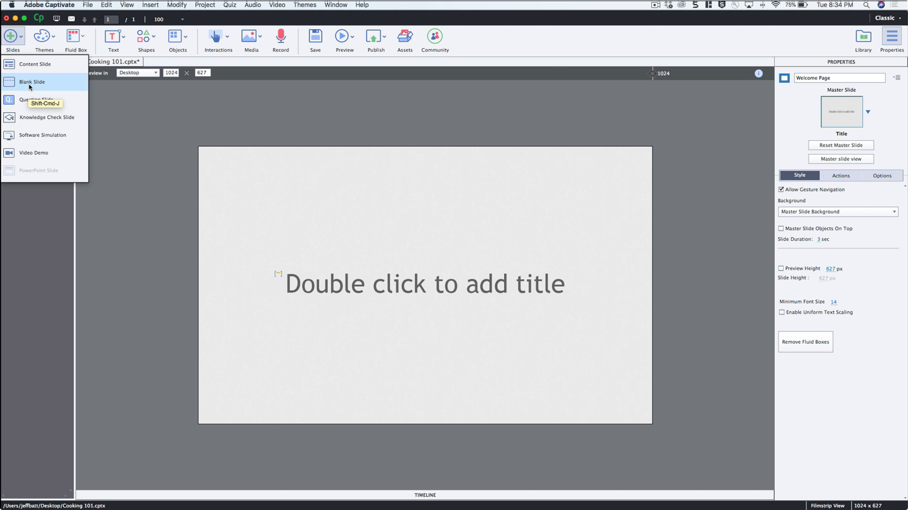

* In the properties of that page, give that page a name of “What is Cooking 101”

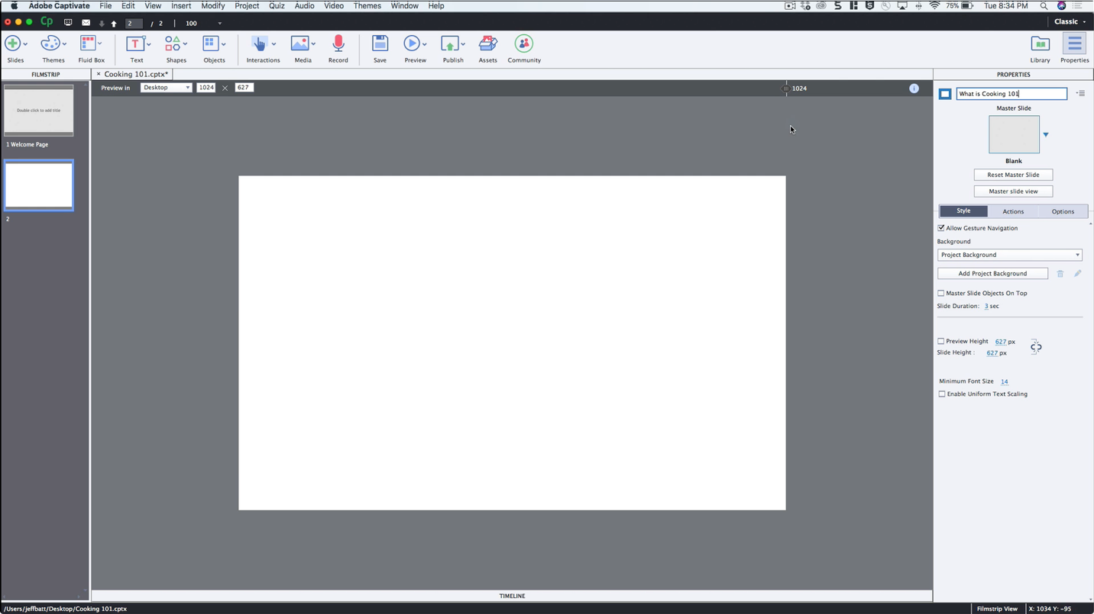

* Create 1 more page by clicking on Slides > Blank Slide

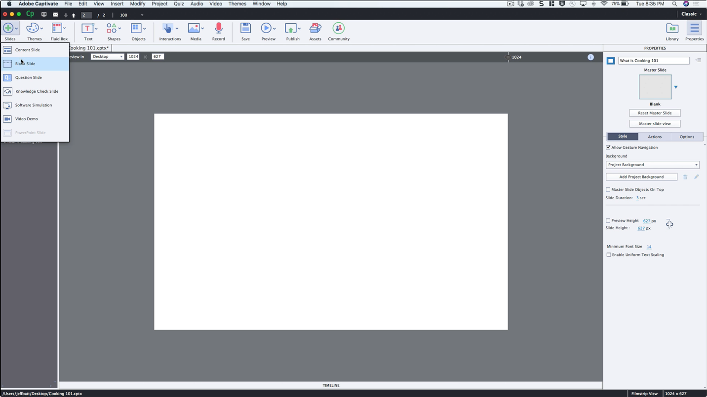

* Go into the properties and name that page “Video Page”

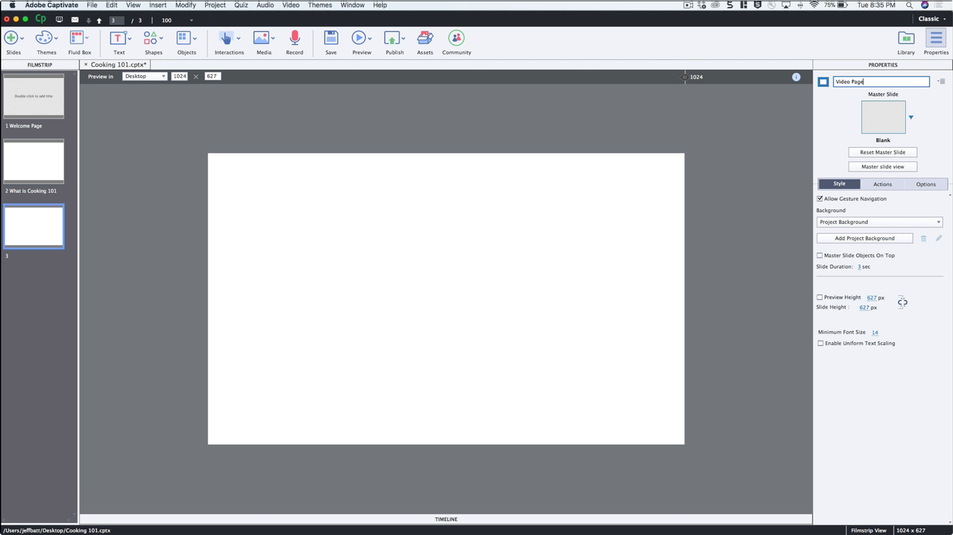

* Go back into page 1 and delete the main title on page 1

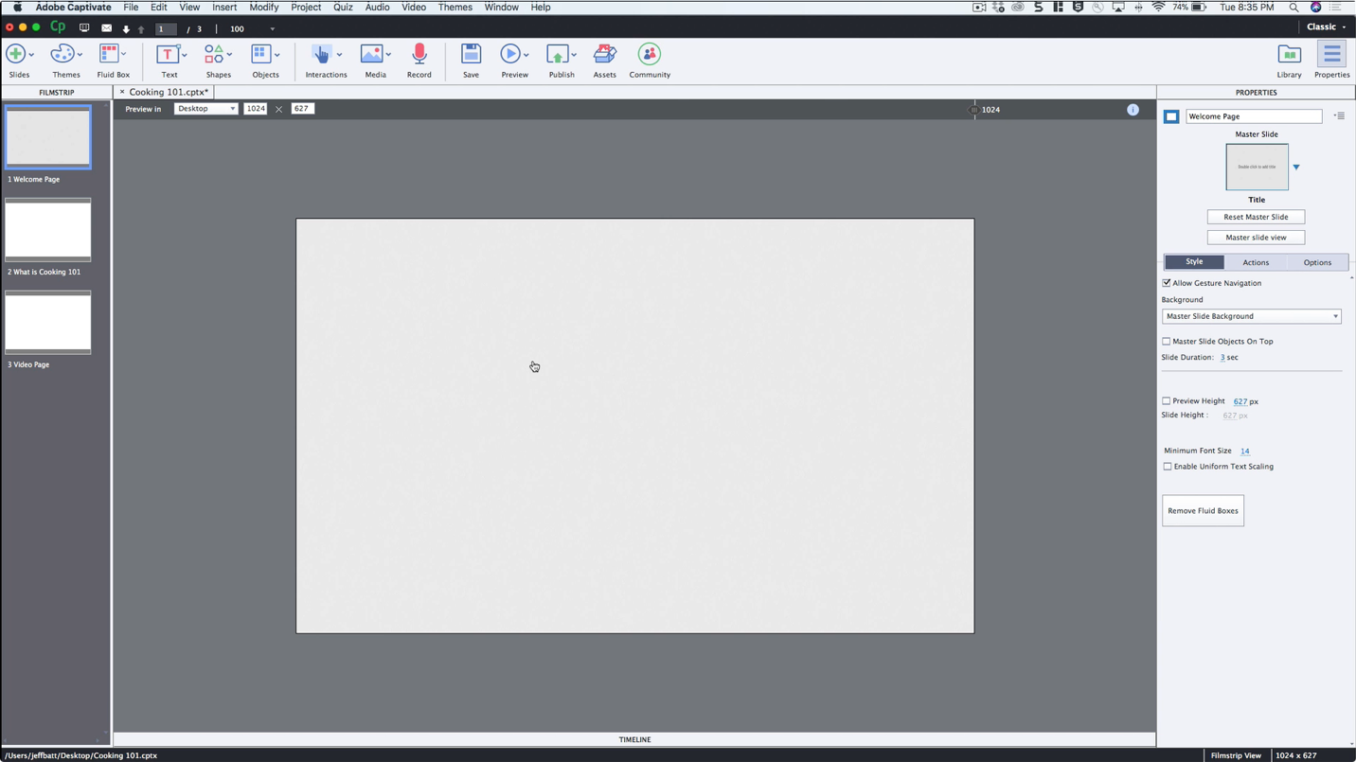

**Section 2**

* Find something on the web like a cooking calculator or something were the user has to interact and have that pulled up in a browser. We are going to show the user how to use this.

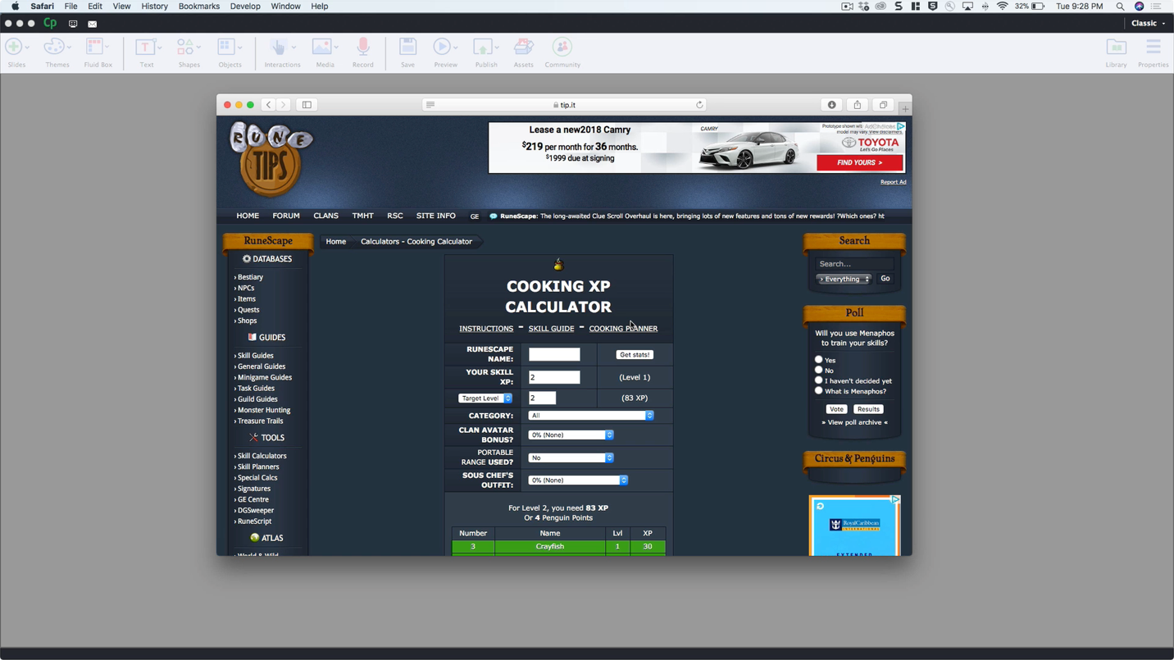

* Go back into Captivate and create new software simulation project. NOTE: We are not using the Cooking 101 project for this section. We are using a new project.

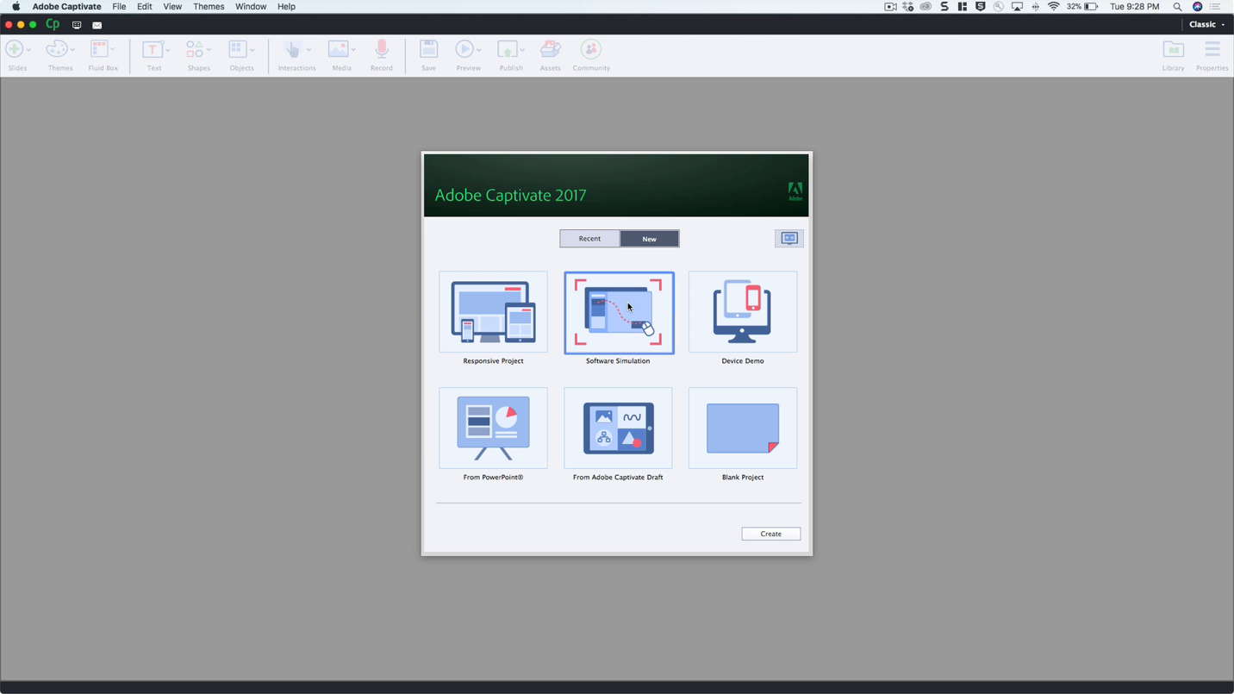

* Drag the red area over the area you want to record. NOTE: You can adjust the height and width by clicking the bottom right hand corner. In this example though we clicked on application and then selected Safari from the list.

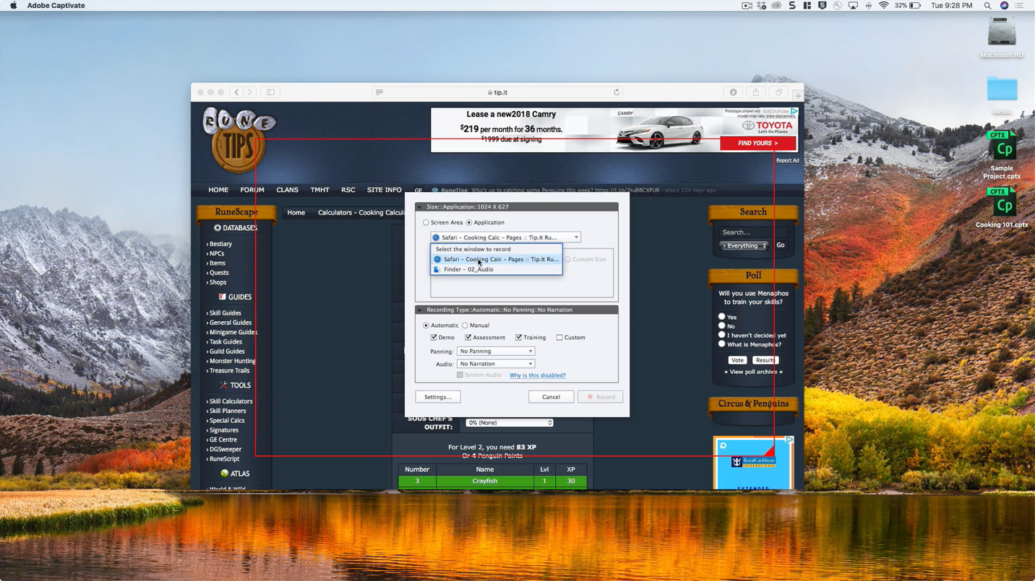

The red outline will automatically adjust to Safari

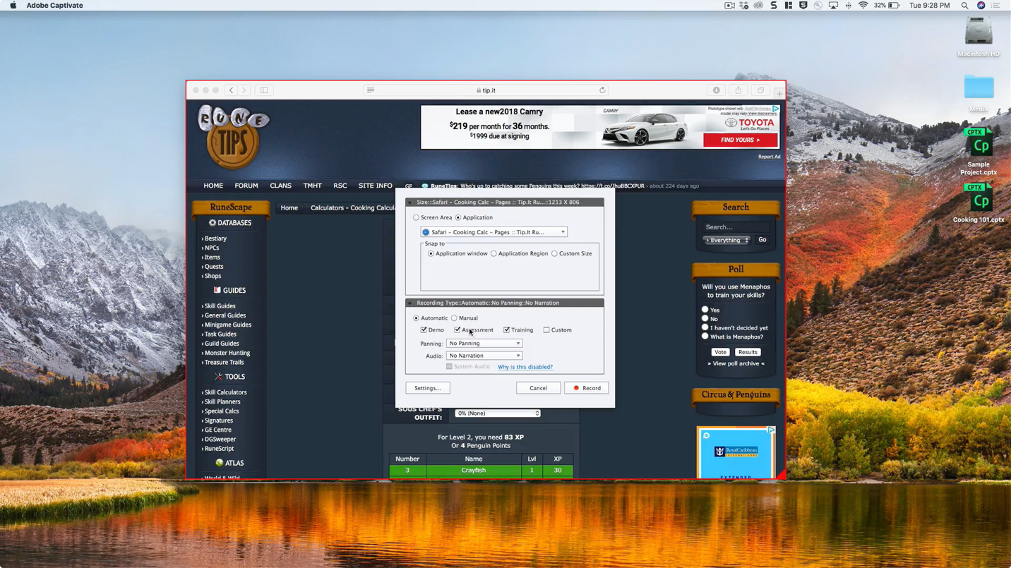

* Adjust the record type to just be demo. So that means you need to uncheck all the other options.

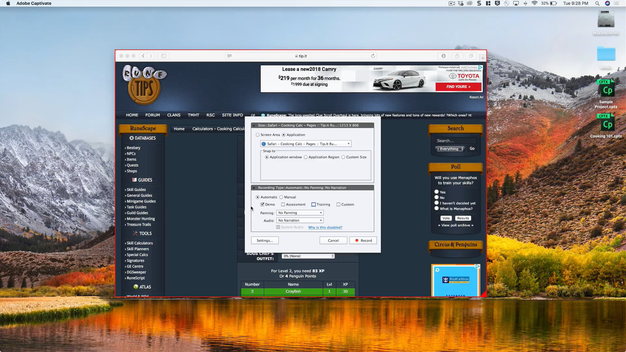

* Hit record, then just walk through your steps

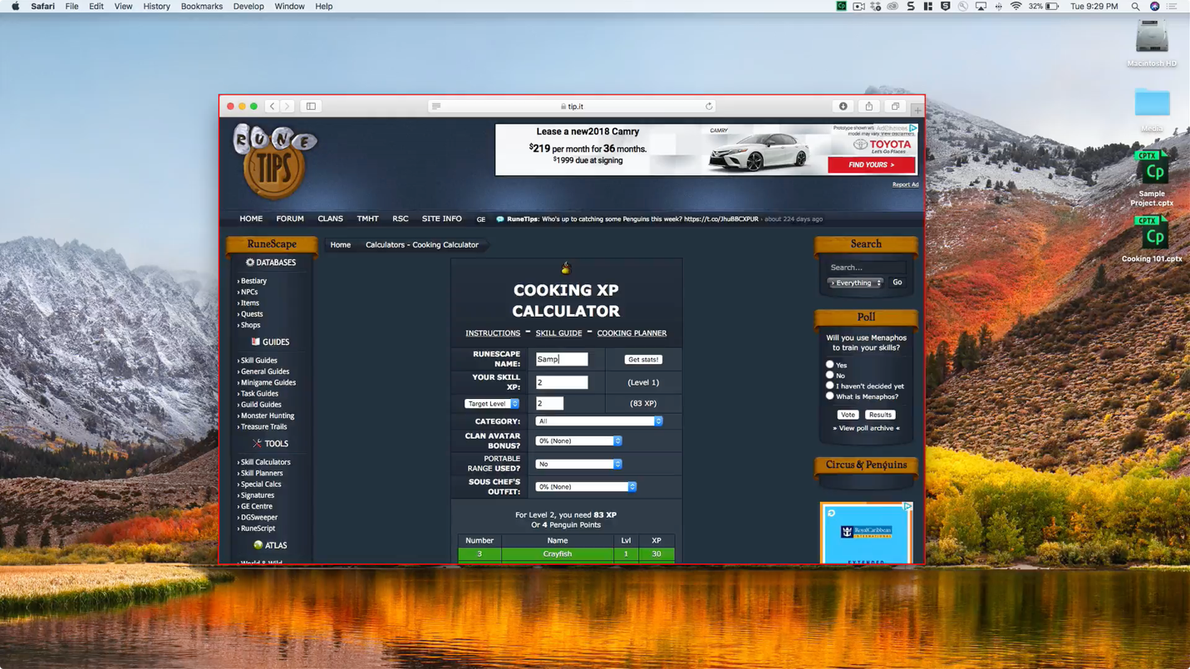

* Once you are done, you can stop recording by clicking the Captivate Icon on top or using the short cut key.

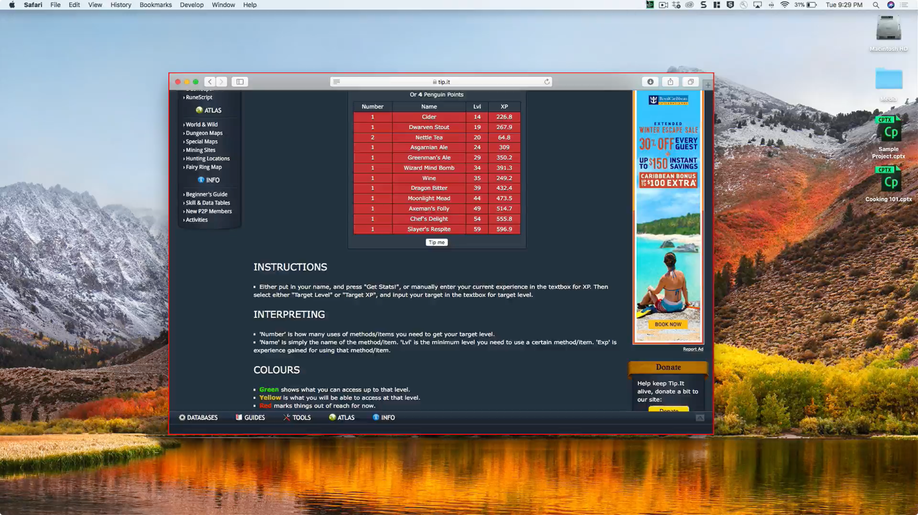

* Slides will get added to your Captivate project and now you can go in and adjust content and animation as needed.

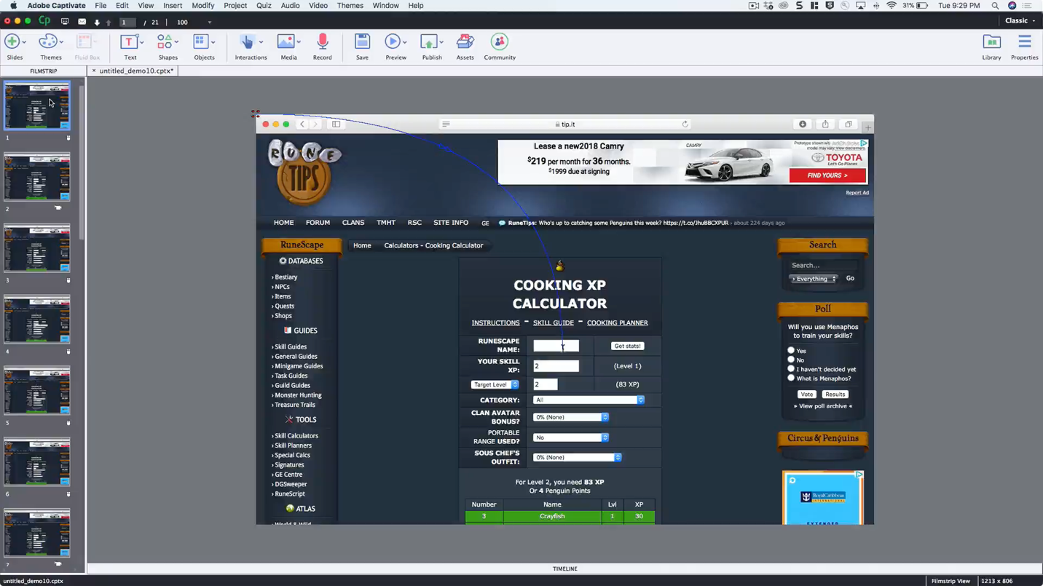

**Section 3**

* Make sure that you open up your Cooking 101 course.
* One page one inset 2 horizontal fluid boxes and get rid of padding

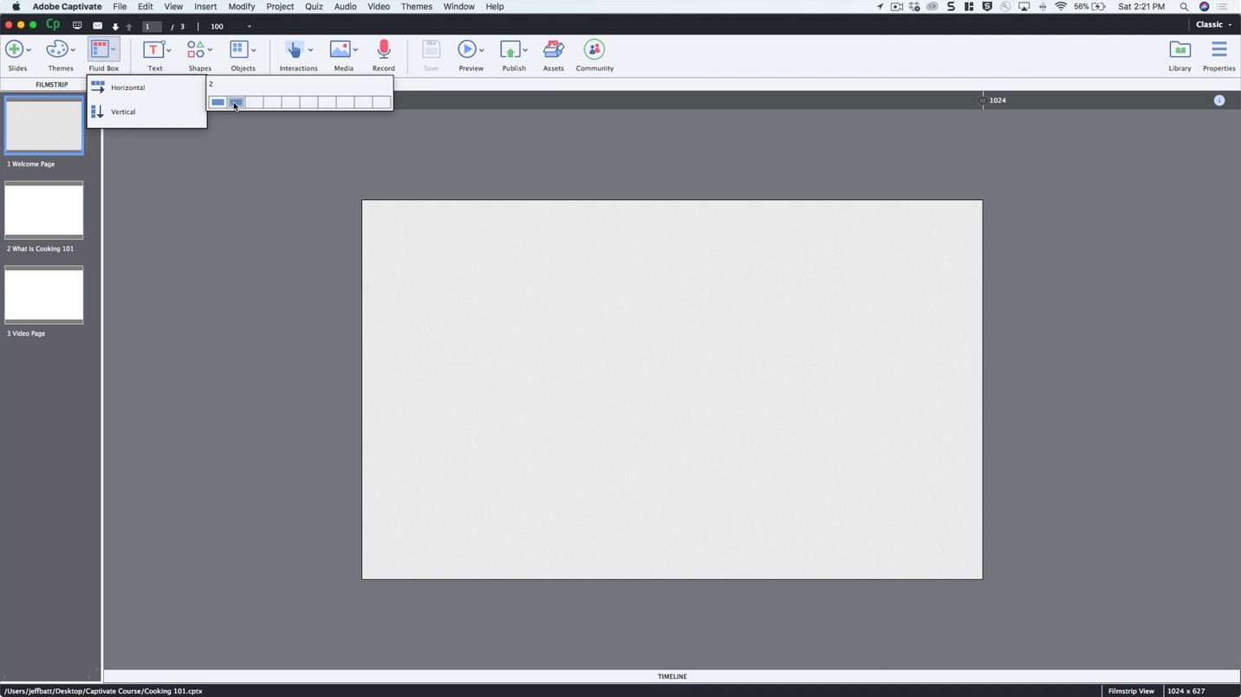

* Adjust the padding of the fluid boxes by going into the properties with one of boxes and clicking on the properties button on the top right. Then under the horizontal section check the box next to the text “Stretch to Fit”

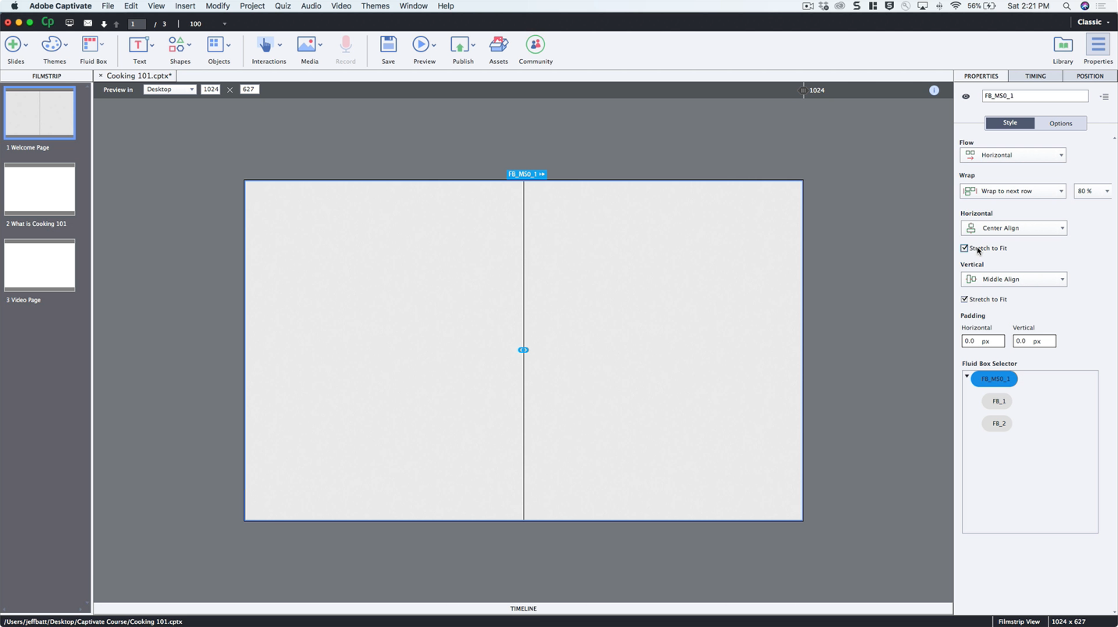

* Create text box with some sample text and drag the text to snap to right fluid box

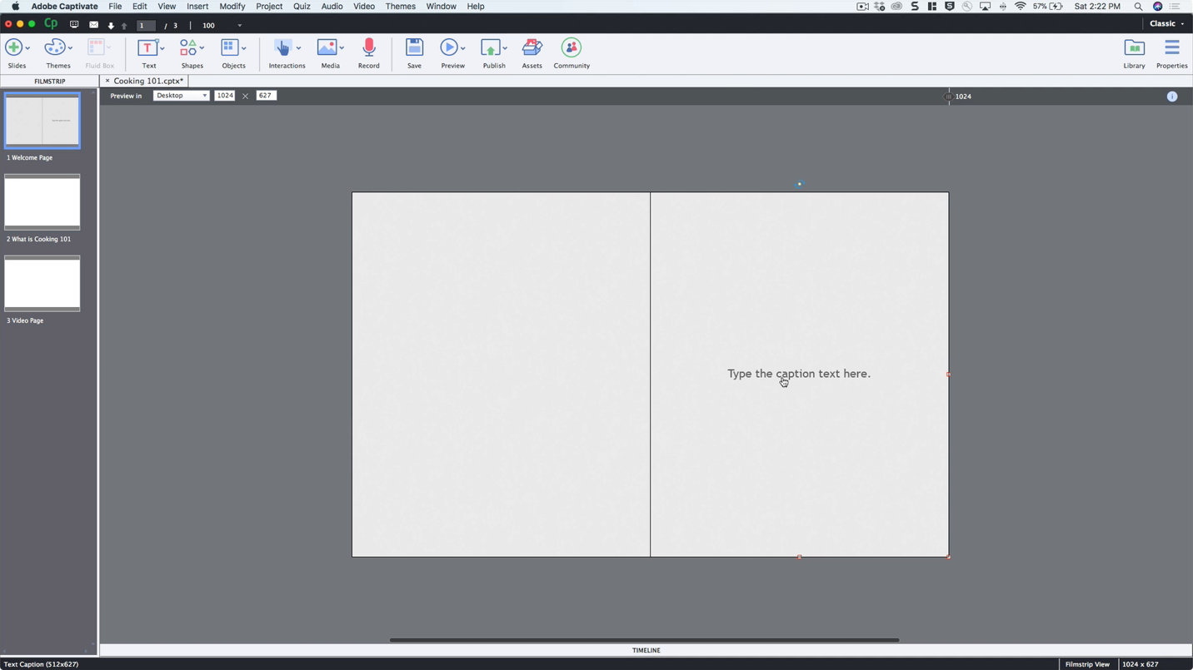

* Open up the properties section and change properties of text box to align top and left.

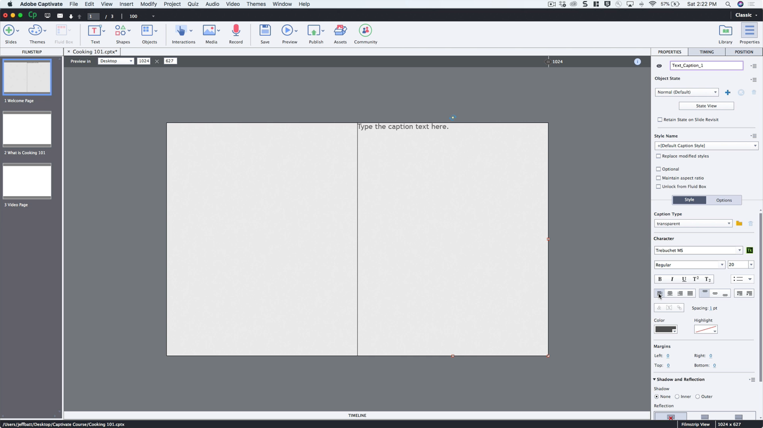

* Select the fluid box by hovering by the line until it turns blue. In the properties add some padding to the box (20px on top and 40 px left).

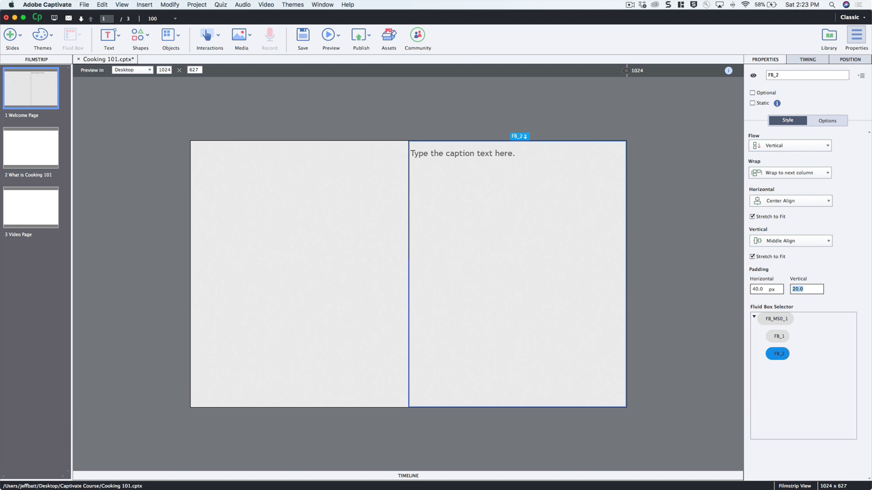

* Go to the lorem ipsum website and copy and paste lorem ipsum text for sample text into your text field just so we have more text.

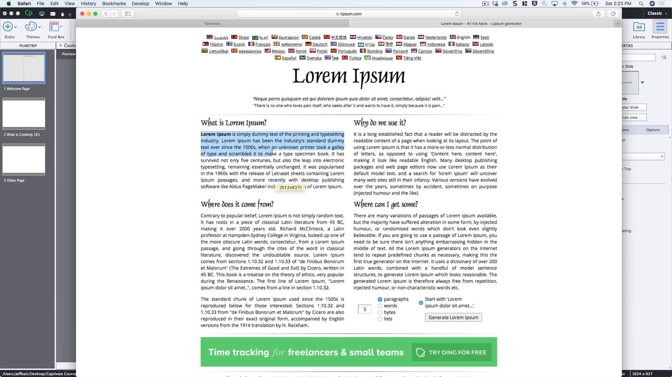

Then paste into Captivate.

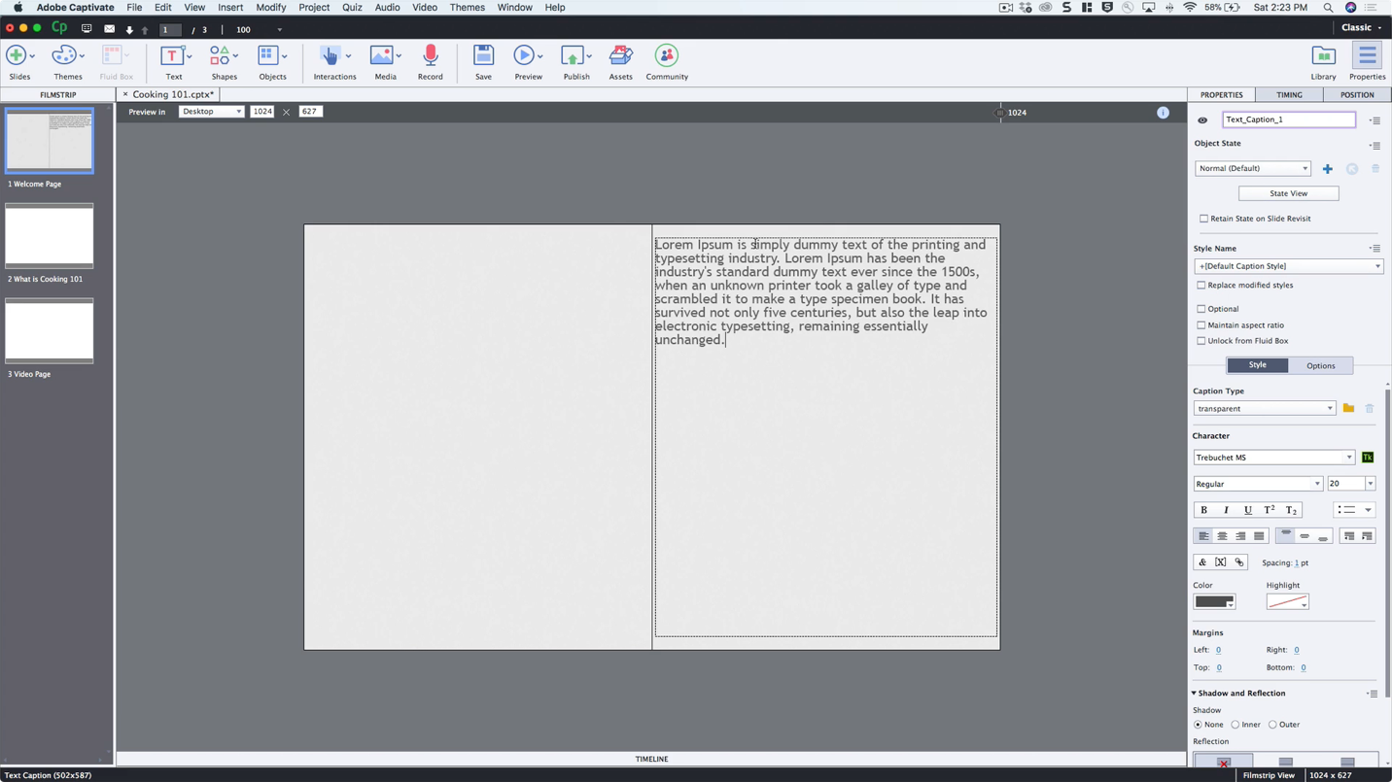

* We need to insert a person. So click on assets and then find a person from the assets.

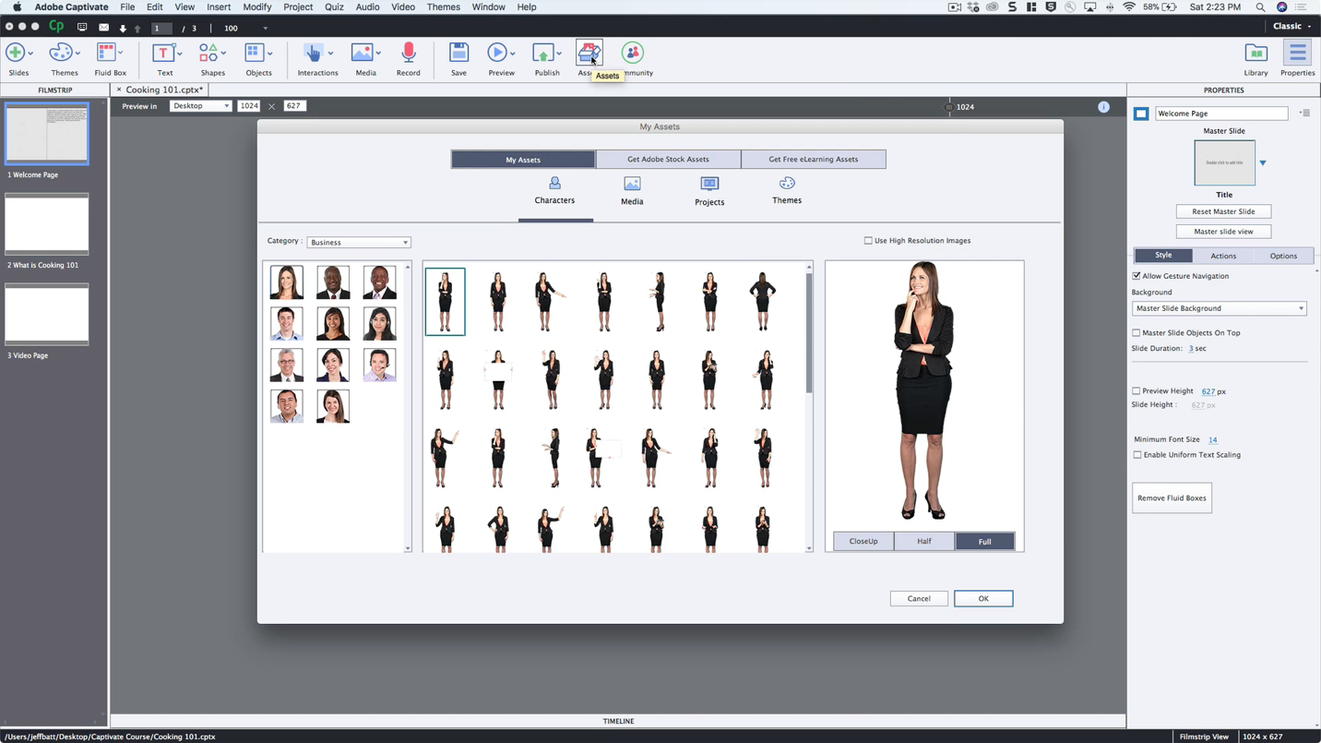

* That person will be inserted right in the middle so click and drag that person over to the left fluid box.

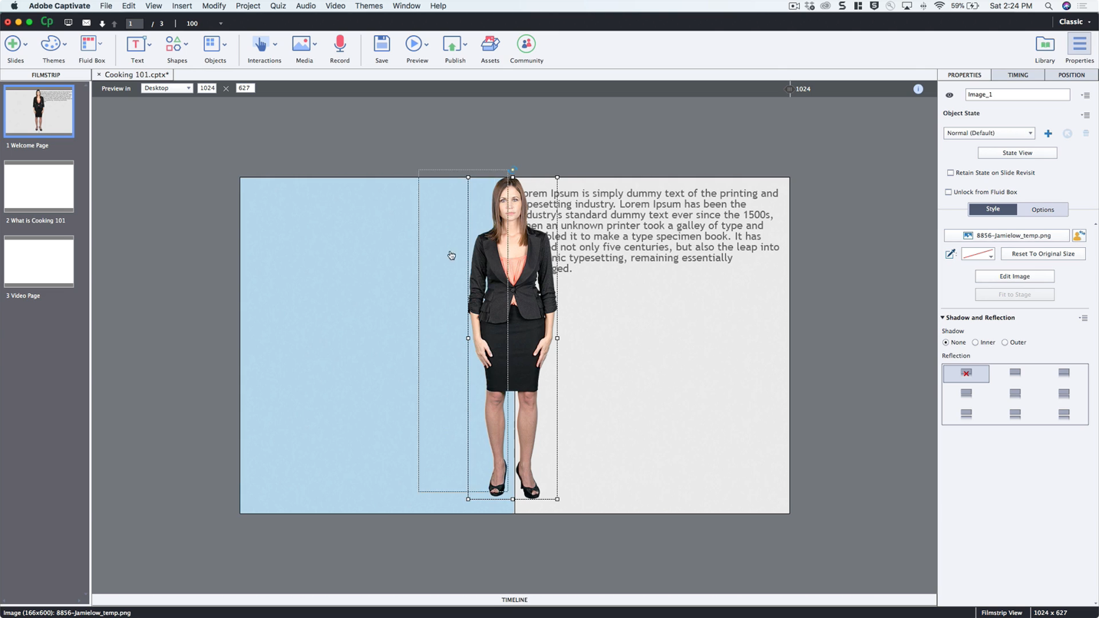

* We need some padding, so she is not flush up against the edges. Click on the fluid box and then add on some padding to the box. (20px)

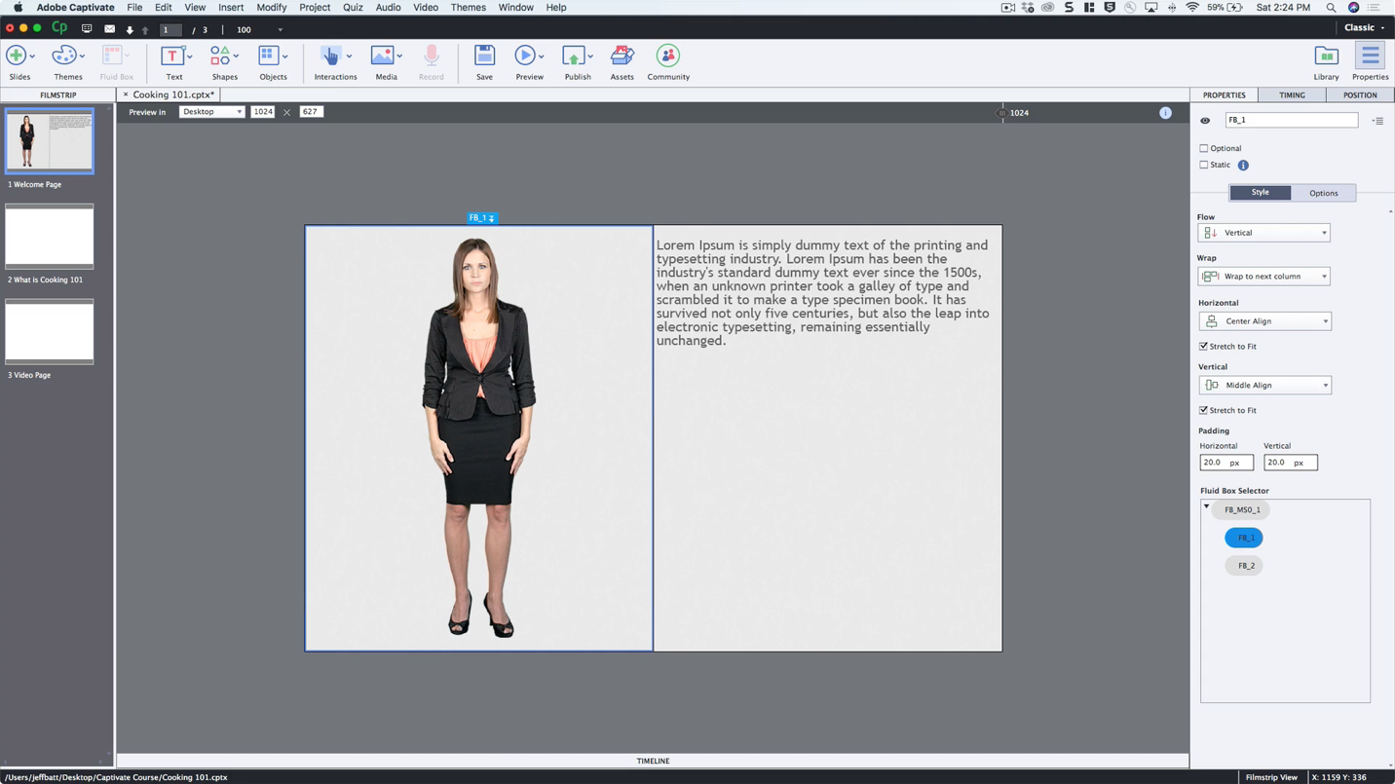

* Now let’s go to page 2.

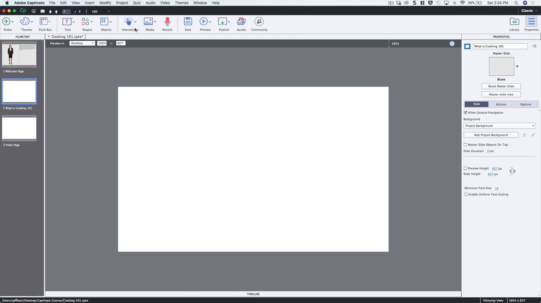

* Click on insert on the top menu and then select “Learning Interactions”.

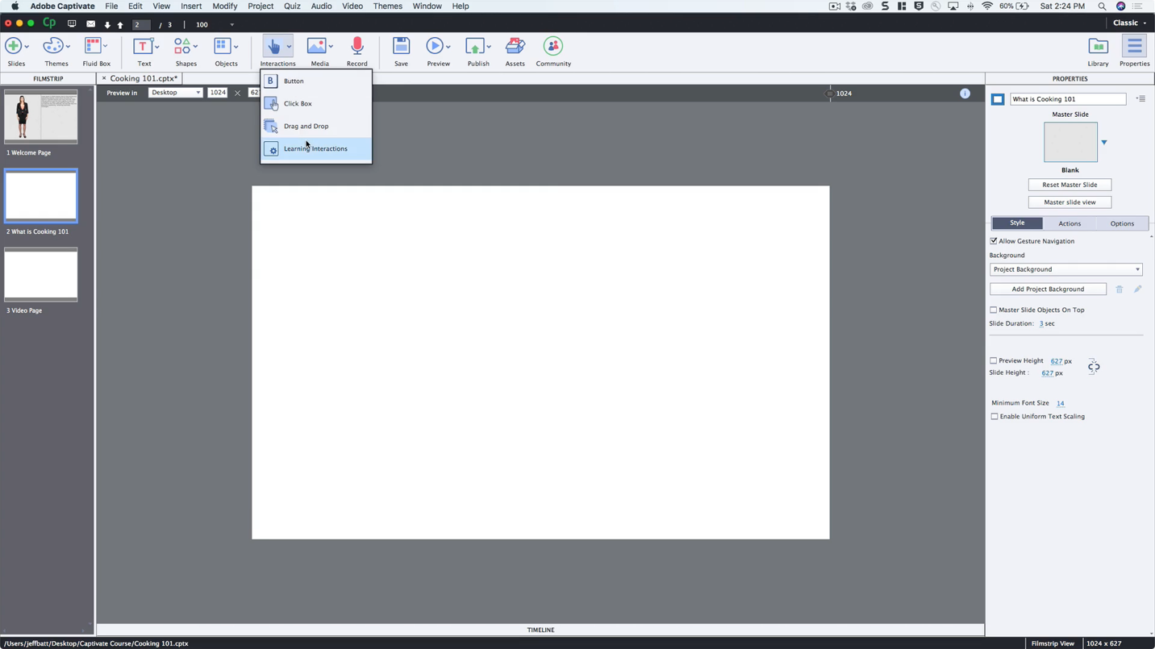

* Scroll through the interactions till you find the Jeopardy game.

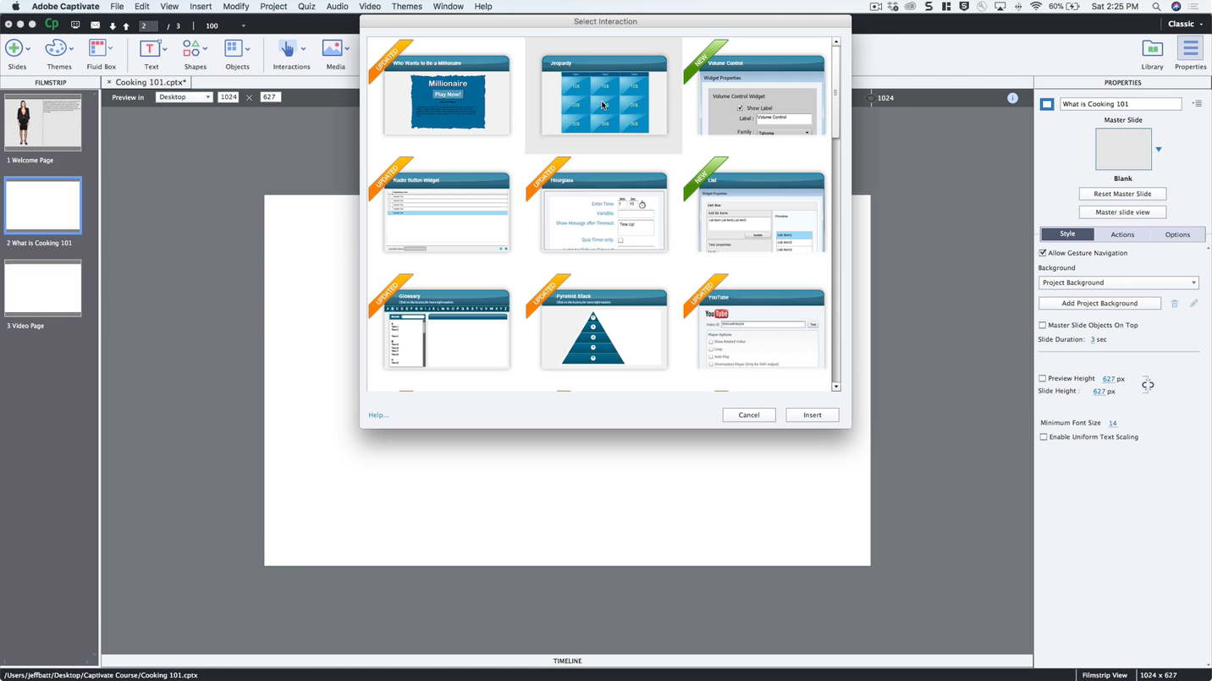

* Once you click that game and click insert, you can start to fill out content for that game

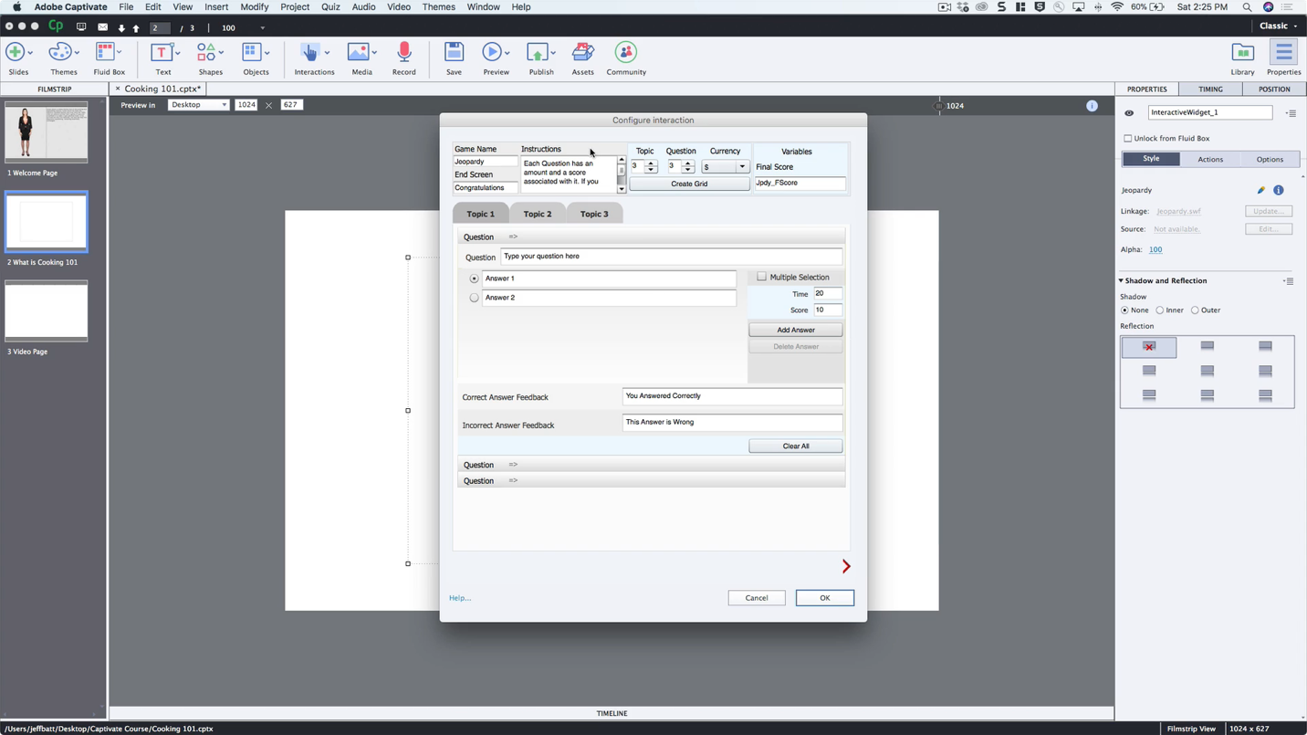

* After you have filled out the content for the game, click ok to insert the game into your page and then adjust the game how you want.

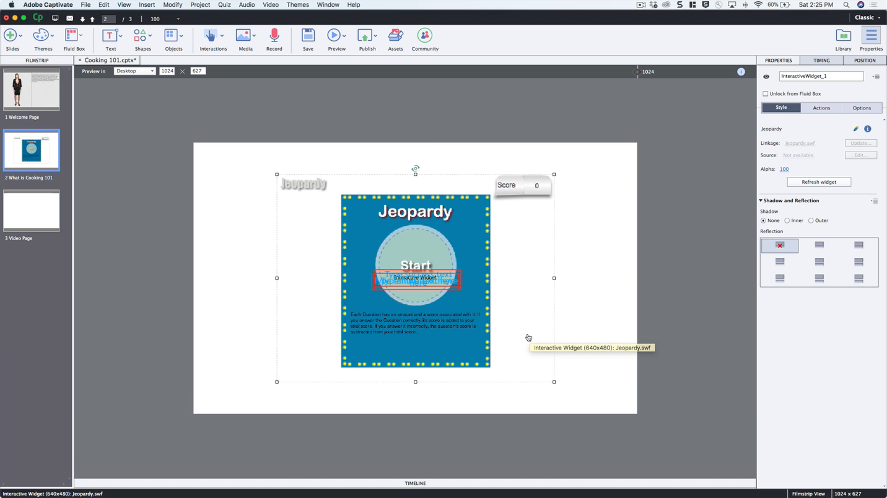

**Section 4**

* Open up Cooking 101 again.

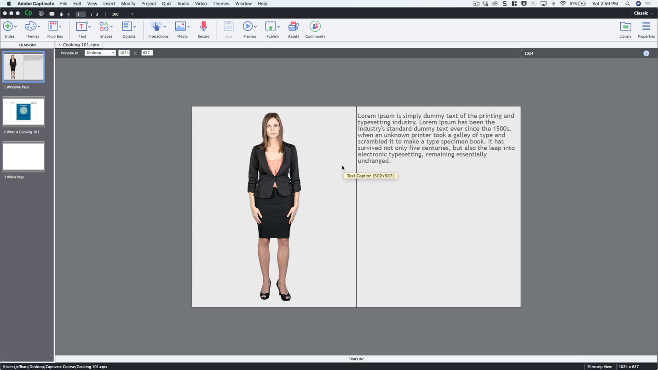

* Delete the person on page 1 inserted from the last section

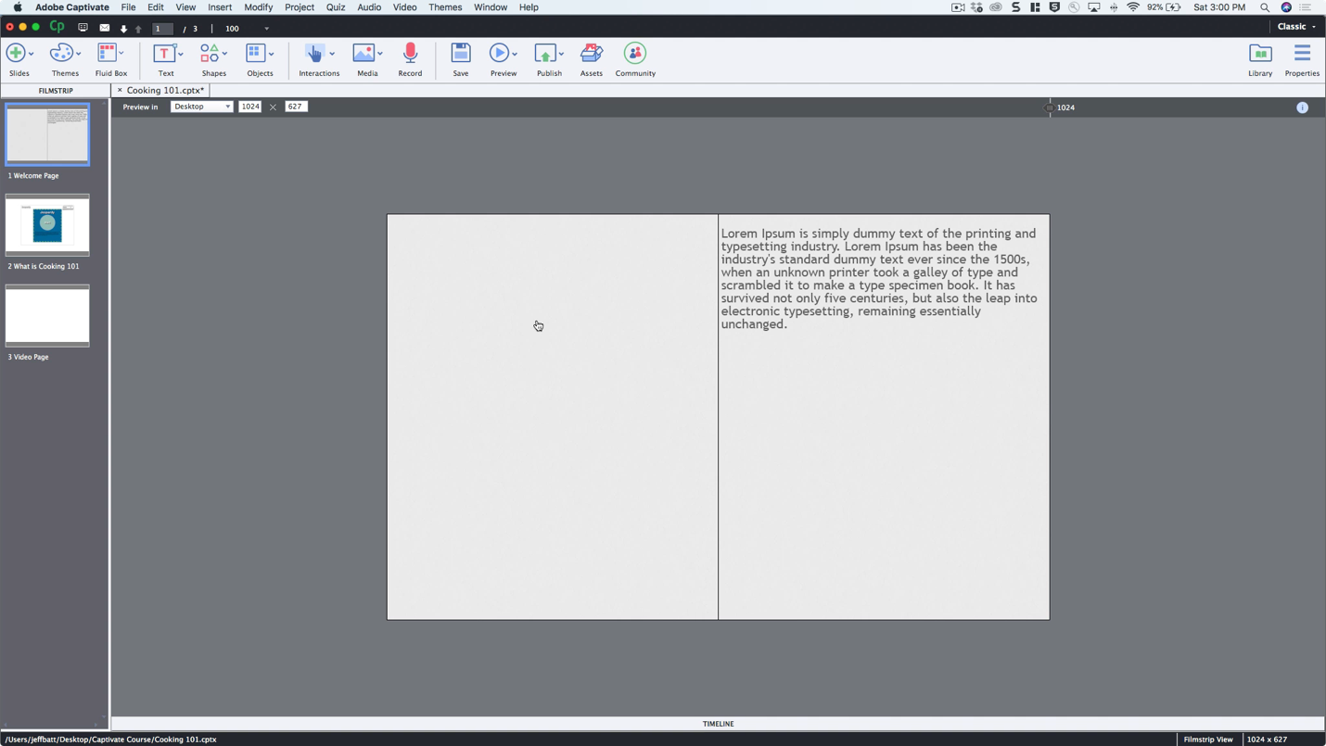

* Within the text, add course title “Cooking 101” in the page text. Bold the font and make it larger. Make sure you bold it and make the font size a little larger.

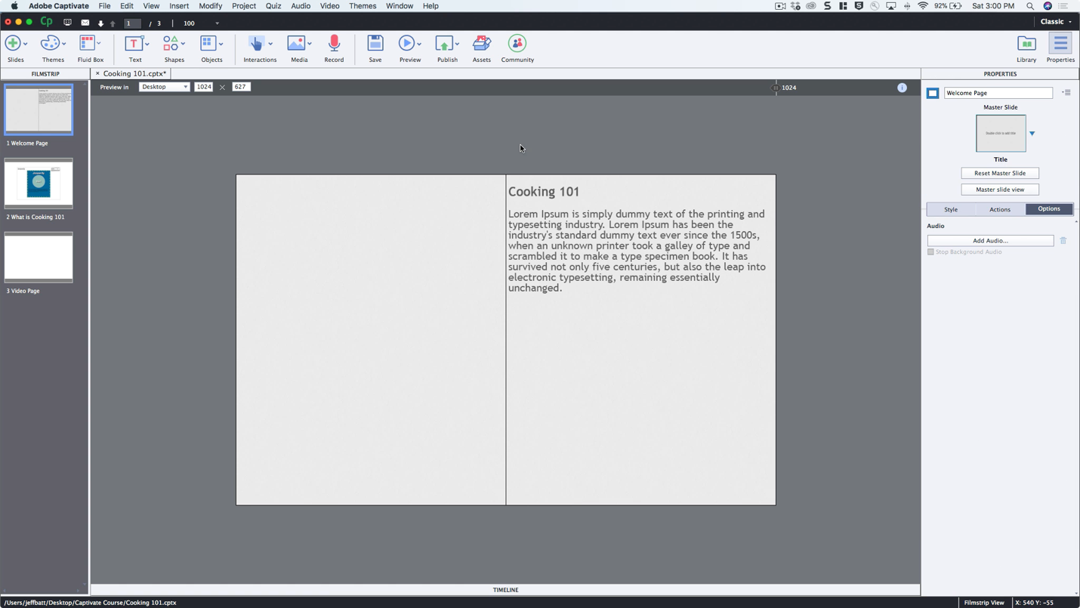

* Now we are going to insert an image so go to Media > Image and find a cooking image from the media folder.

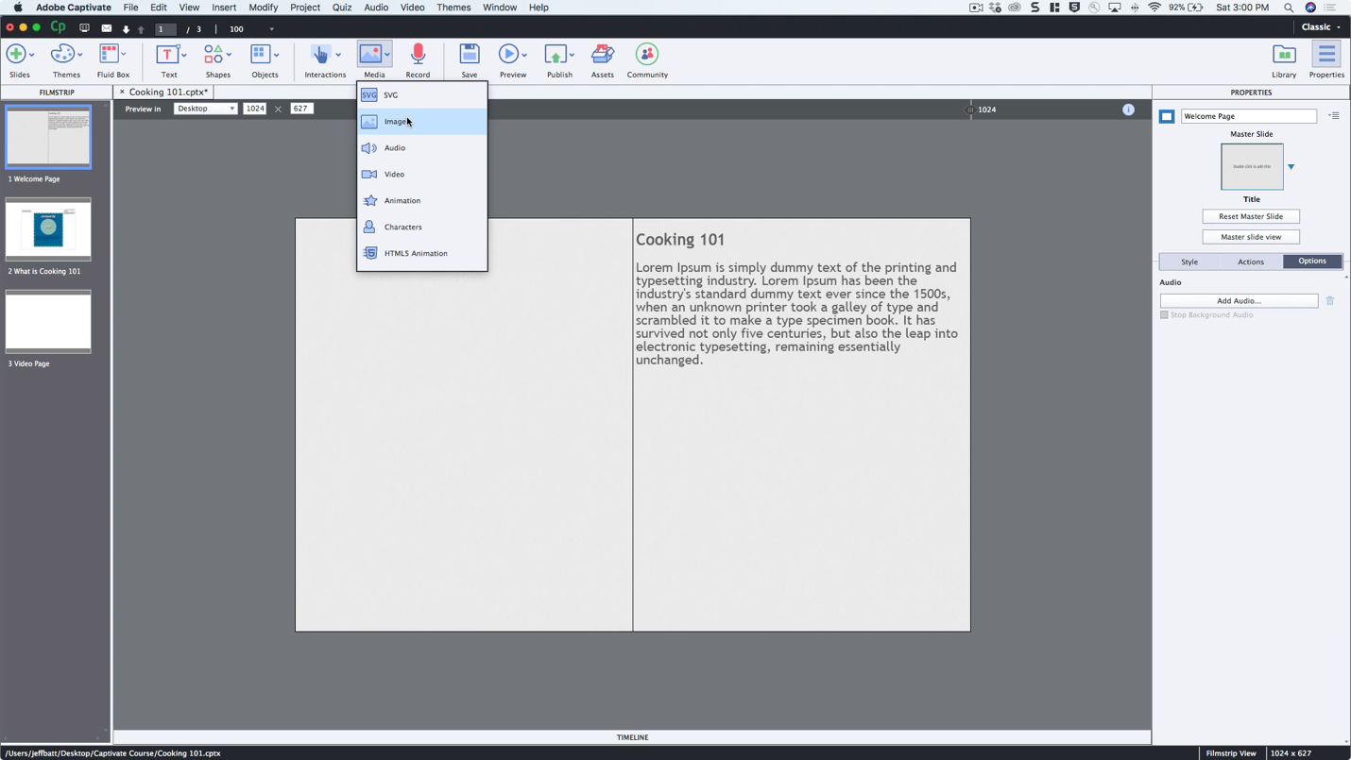

* Once image is inserted click on the image and then within the properties click on “Fit to Stage”

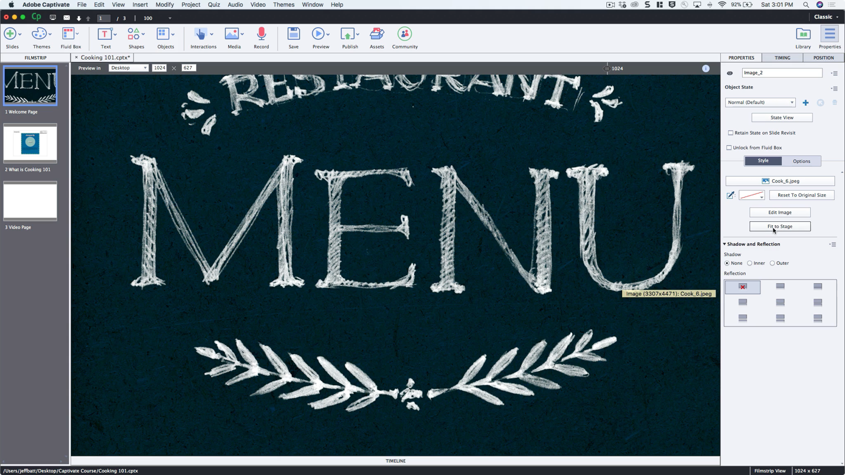

Which will then make it fit within the page.

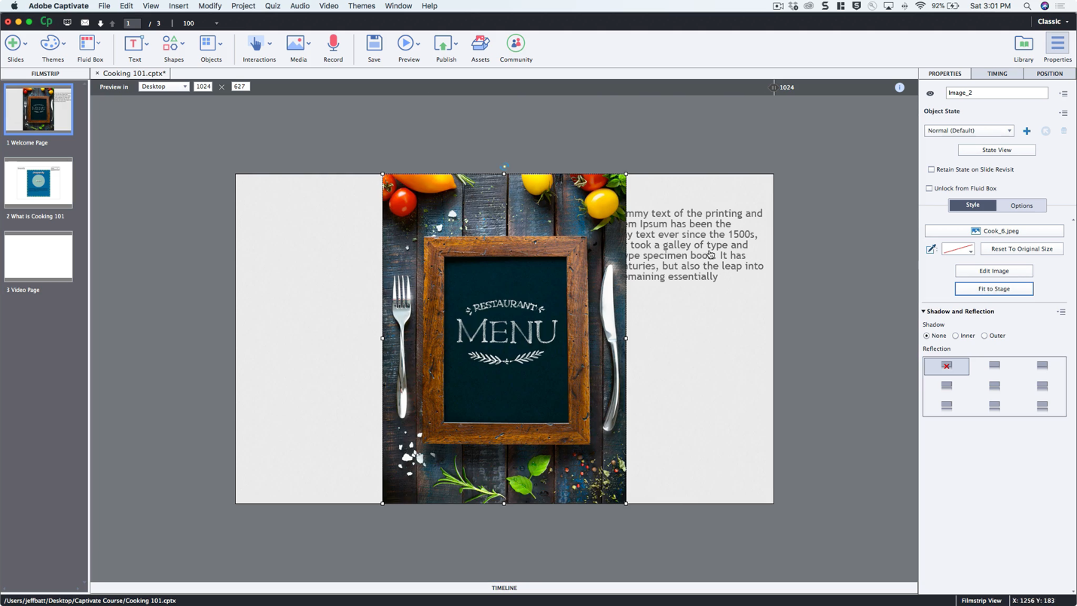

* Drag and drop that image into the left fluid box.

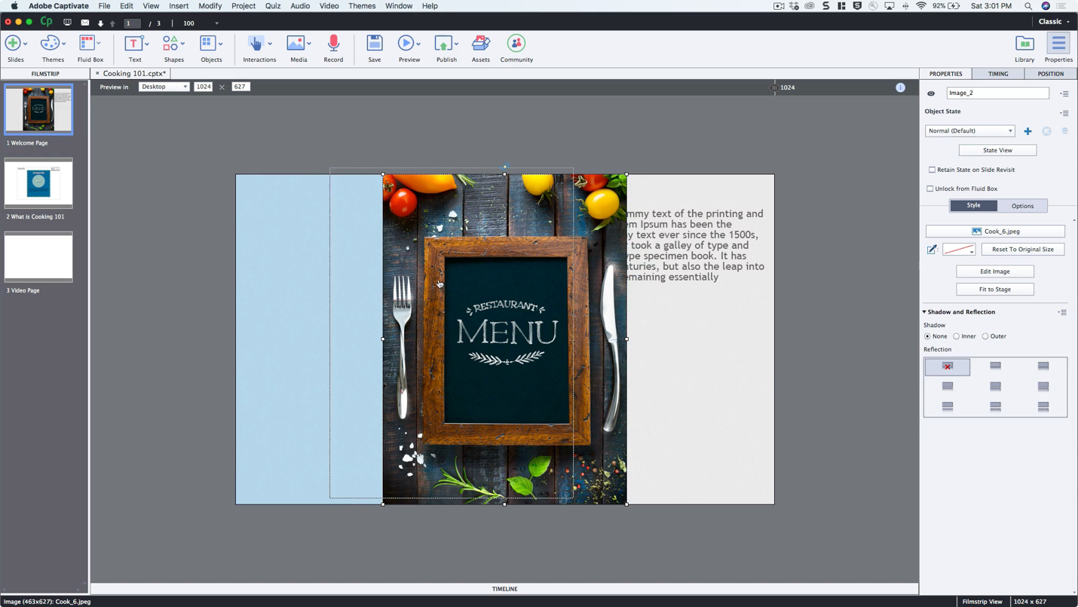

* Now let’s add some audio to the page. Insert some audio into page 1 by clicking on Media > Audio and locate the audio in your media folder.

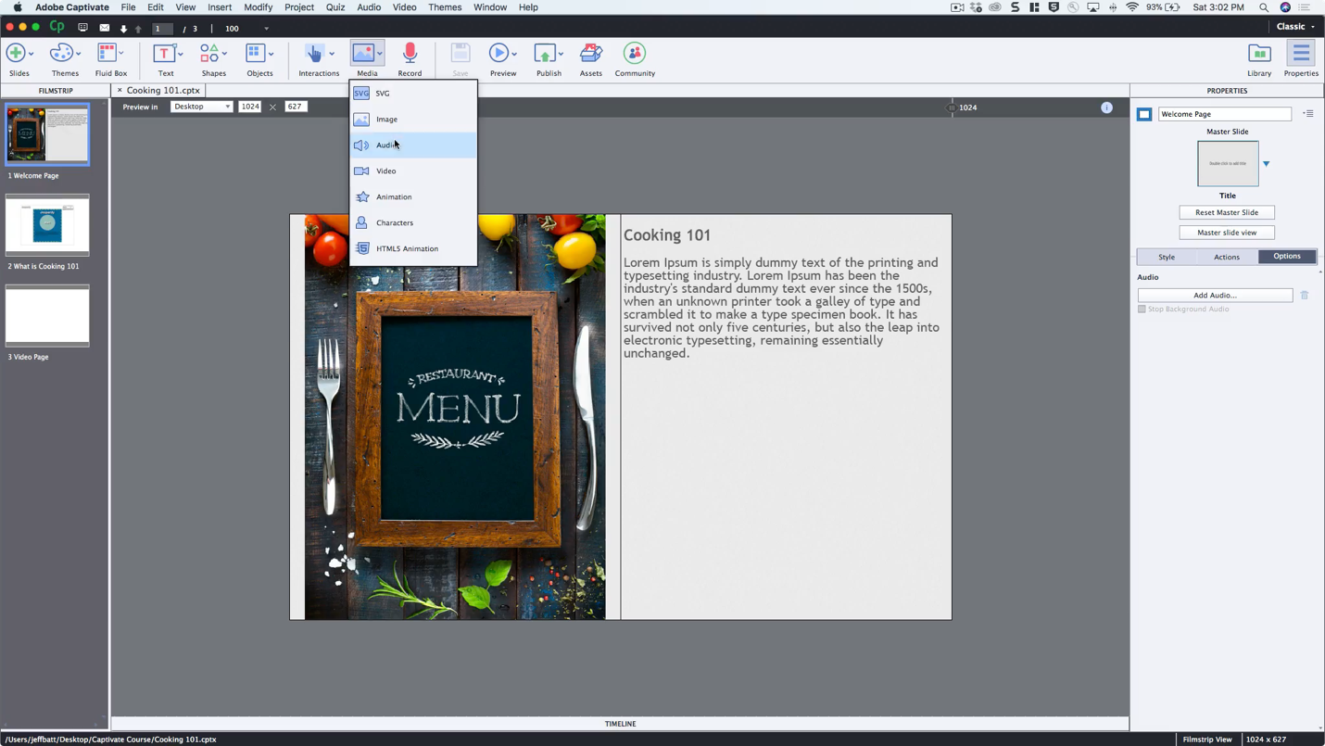

* When the import options show just select the option that will show the slide for the same amount of time as the audio then click ok to insert the audio.

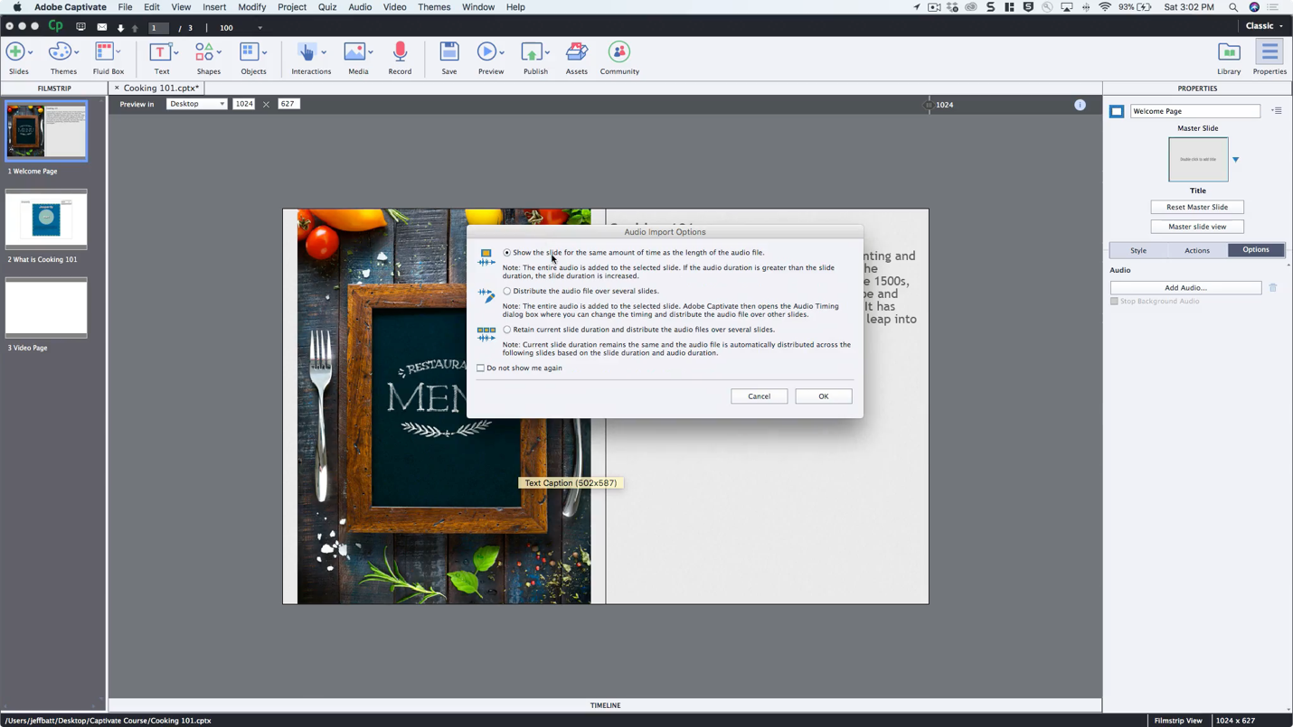

* Click the Timeline bar down at the bottom and adjust all options to extend to the length of the timeline audio.

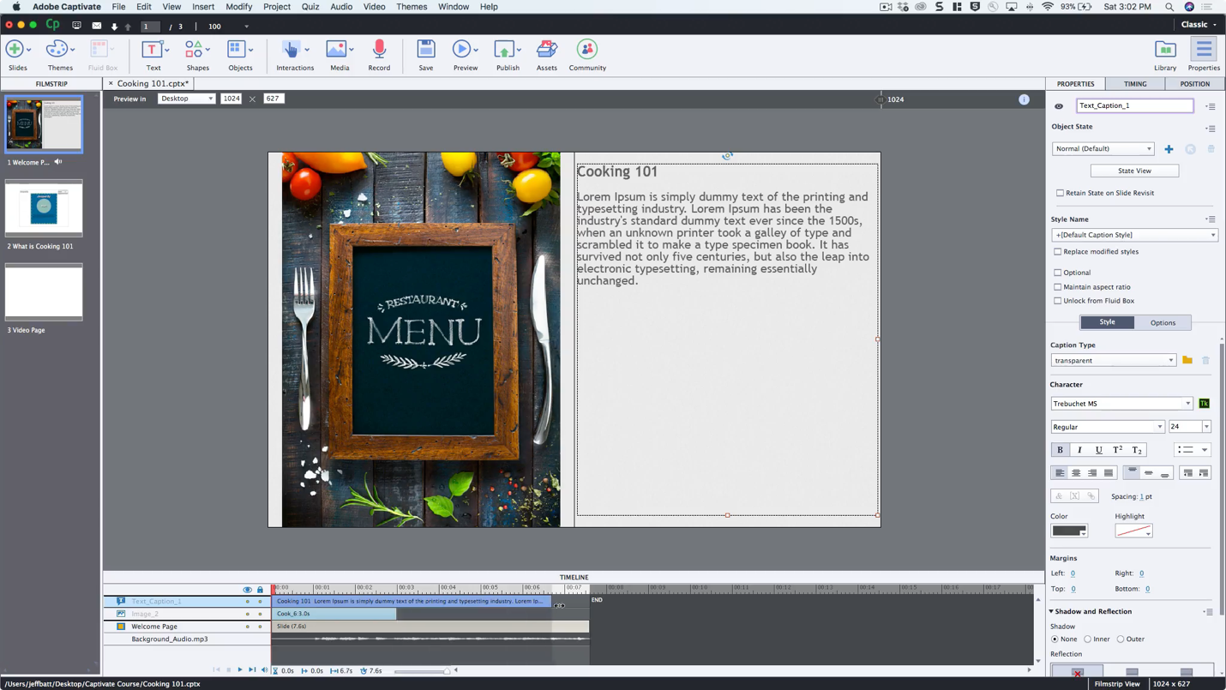

* Go to page 3 and insert a video by clicking media and then video. And then locate your video.

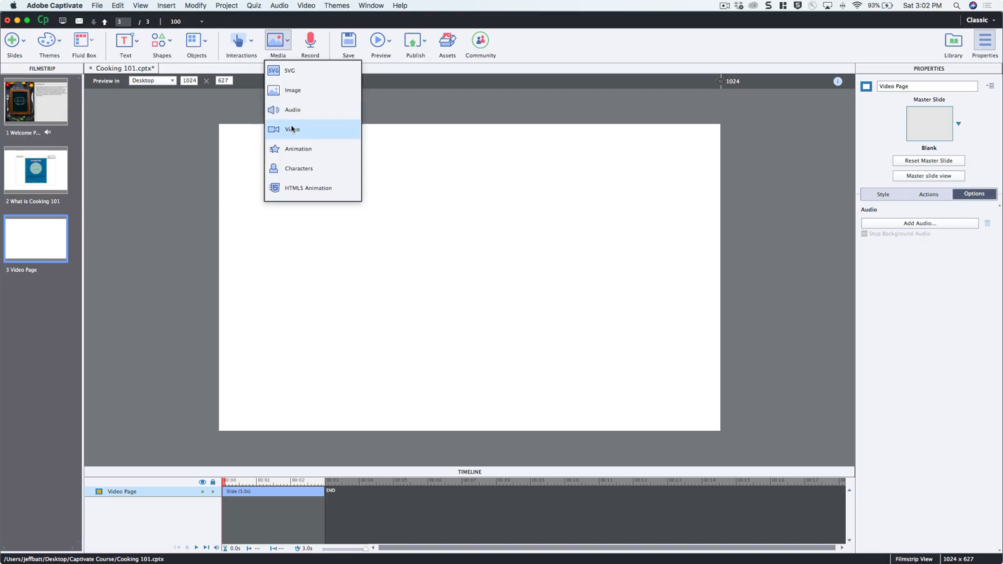

* After the video is inserted into the page, resize video to fit into the stage area.

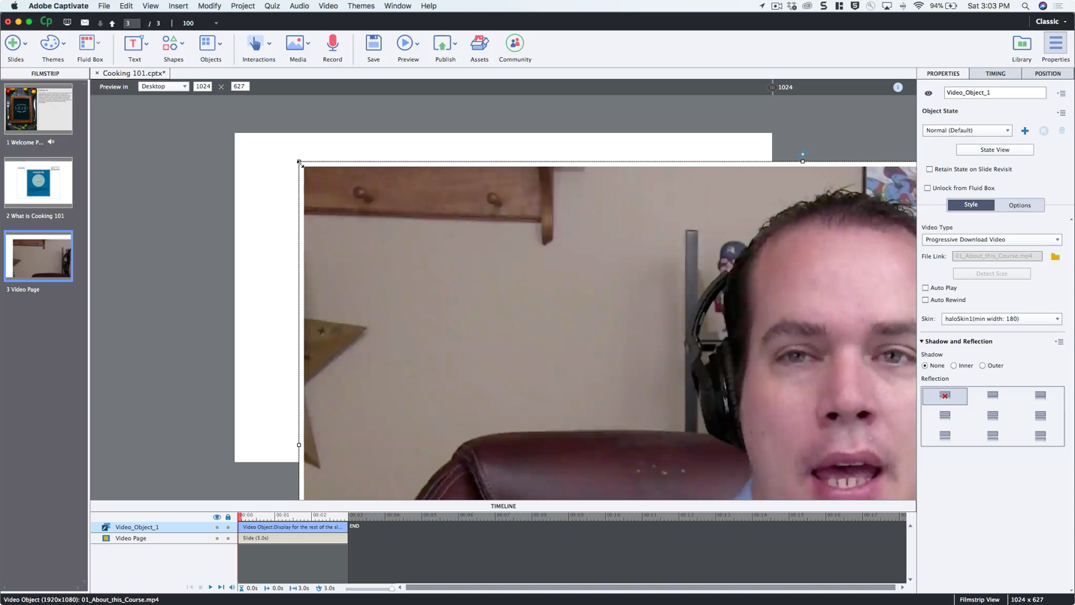

* Let’s insert another page by clicking on Slides > Blank slide.

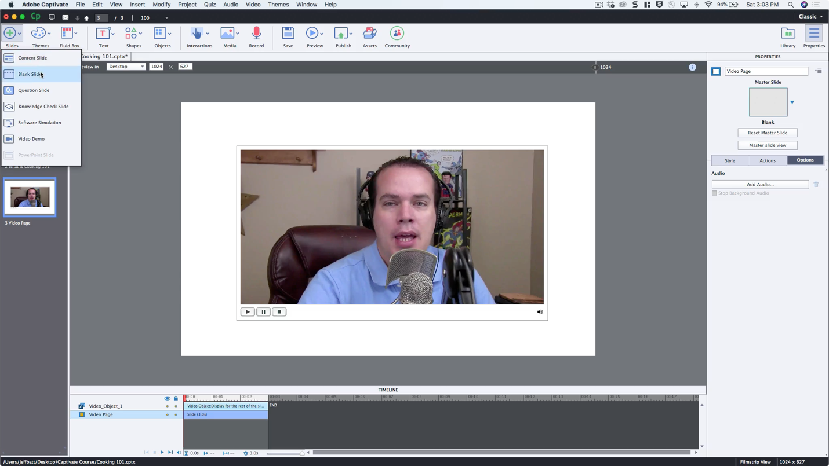

* On this new page we are going to create a background image. In the properties of the page go to Add a background image and import new image by clicking on **Add Project Background**.

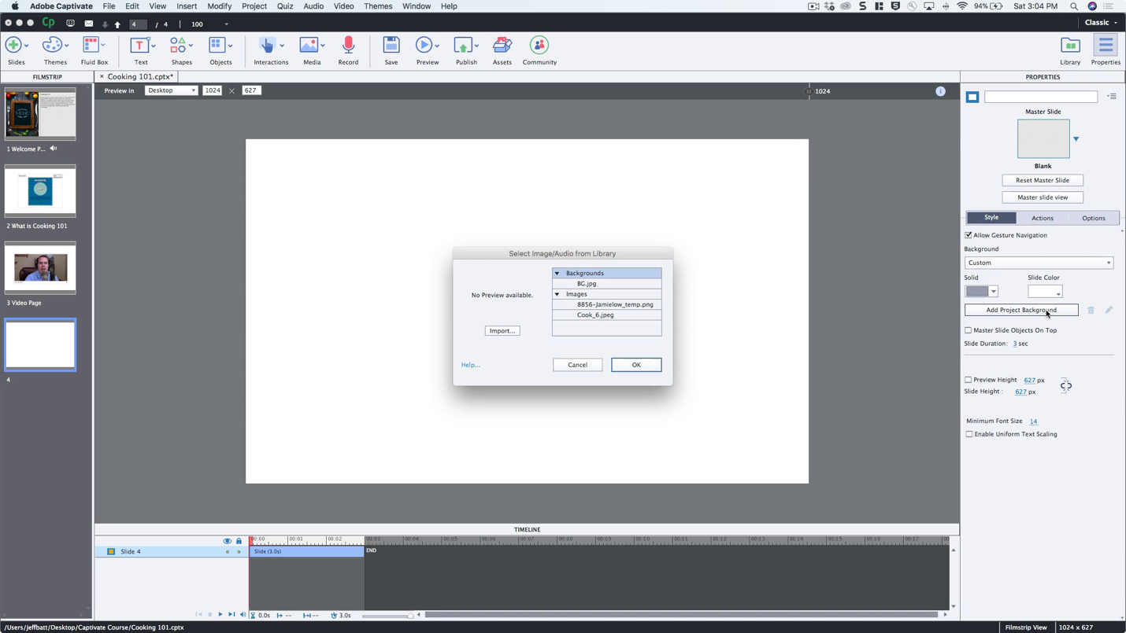

* When you click on that button it gives you a choice of all images in your project or you can click on import to go find another image. You can adjust the image before adding it to your page.

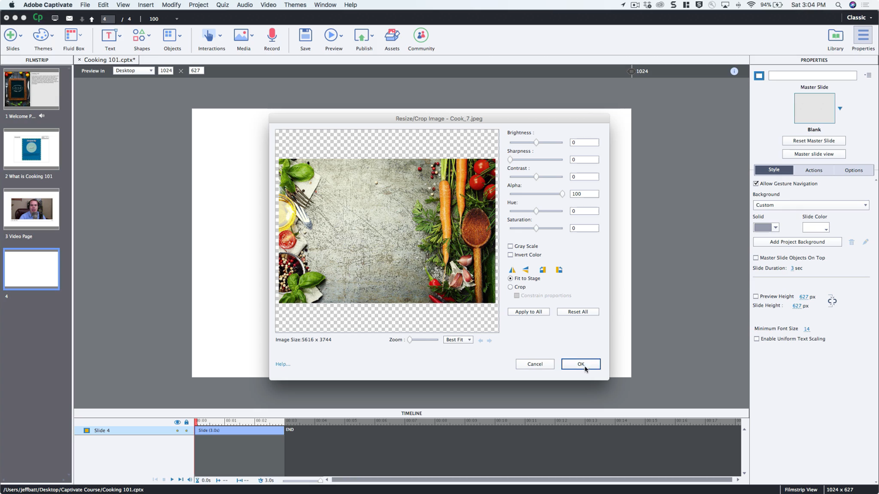

* With the editing enabled, select the crop option and adjust the crop by dragging the blue squares.

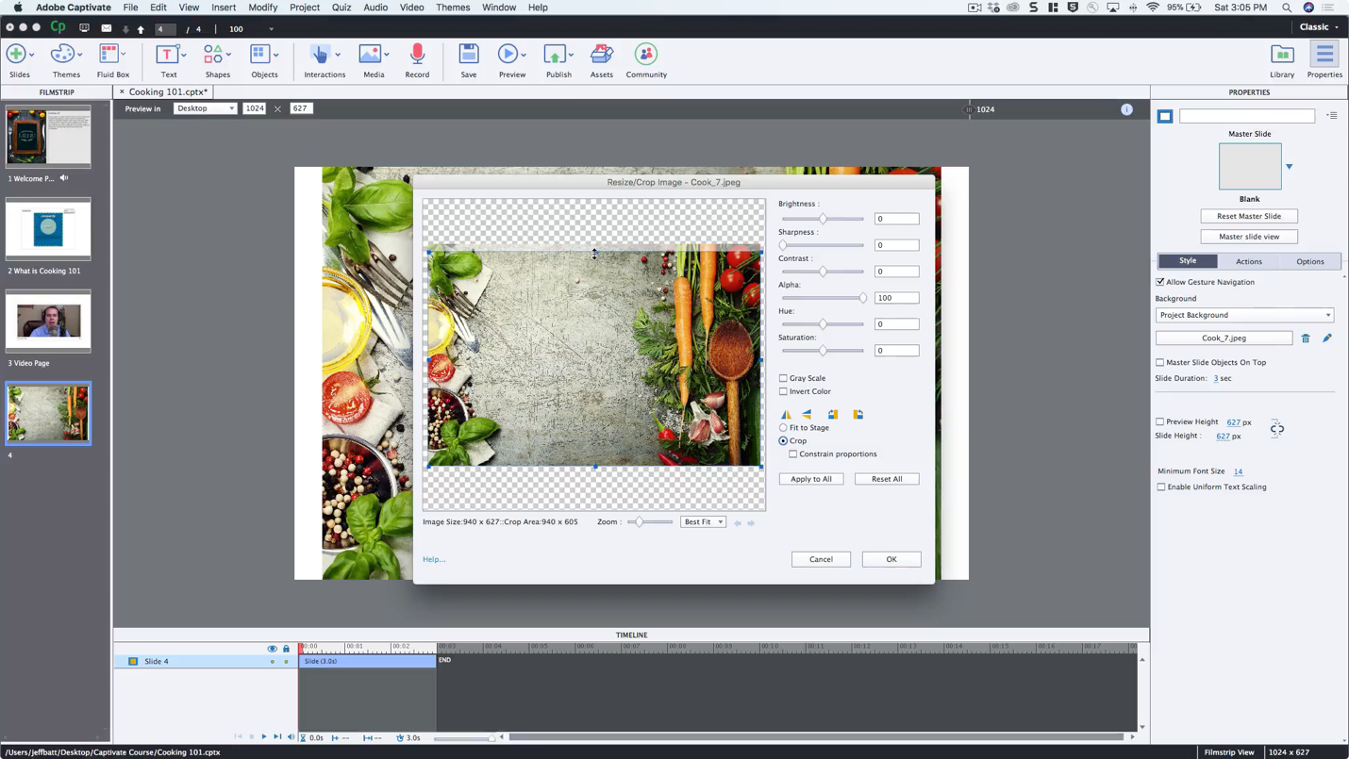

**Section 5**

* Make sure first that you open up your Cooking 101 project.
* Click on the timeline bar to show the timeline.

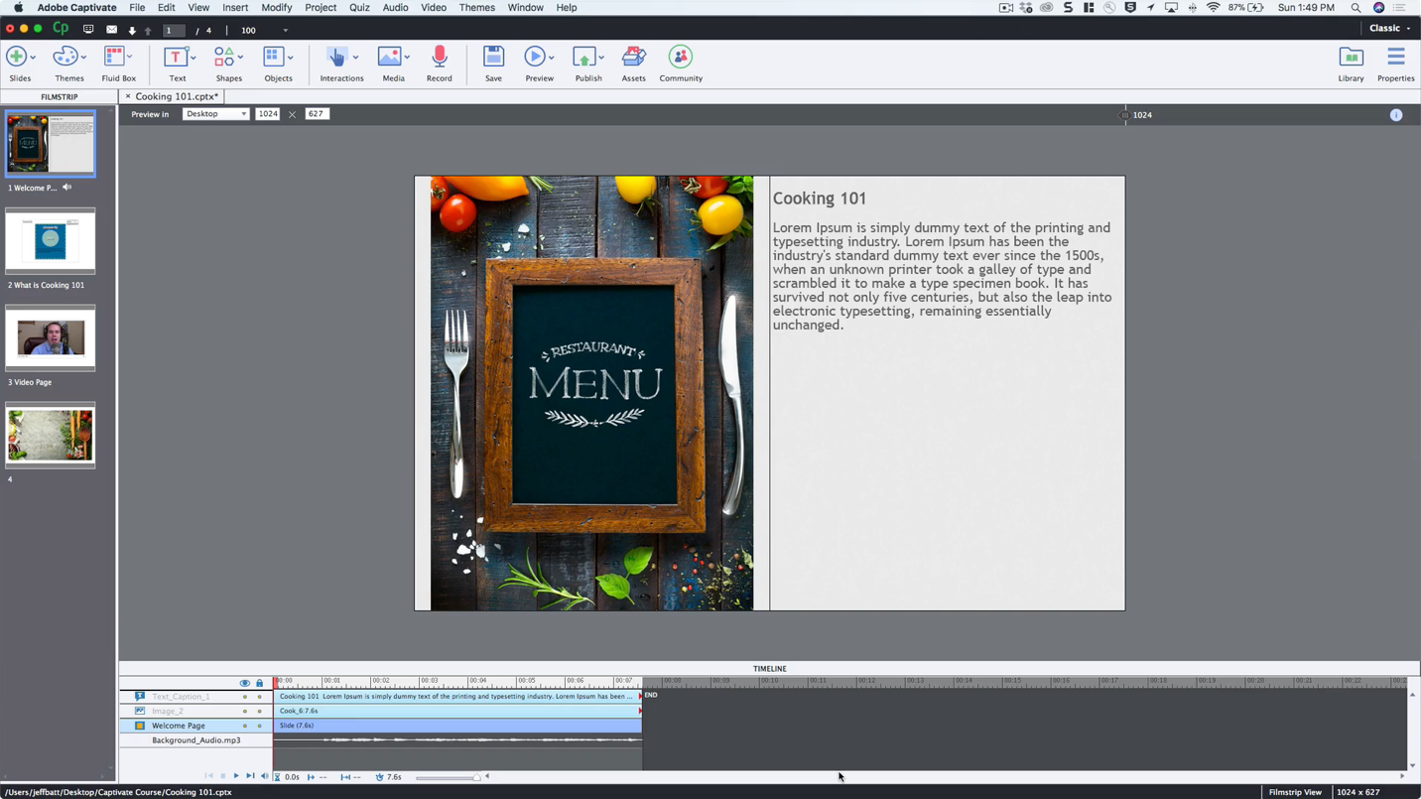

* The first object we want to animate is the image, so make sure you have the image selected.

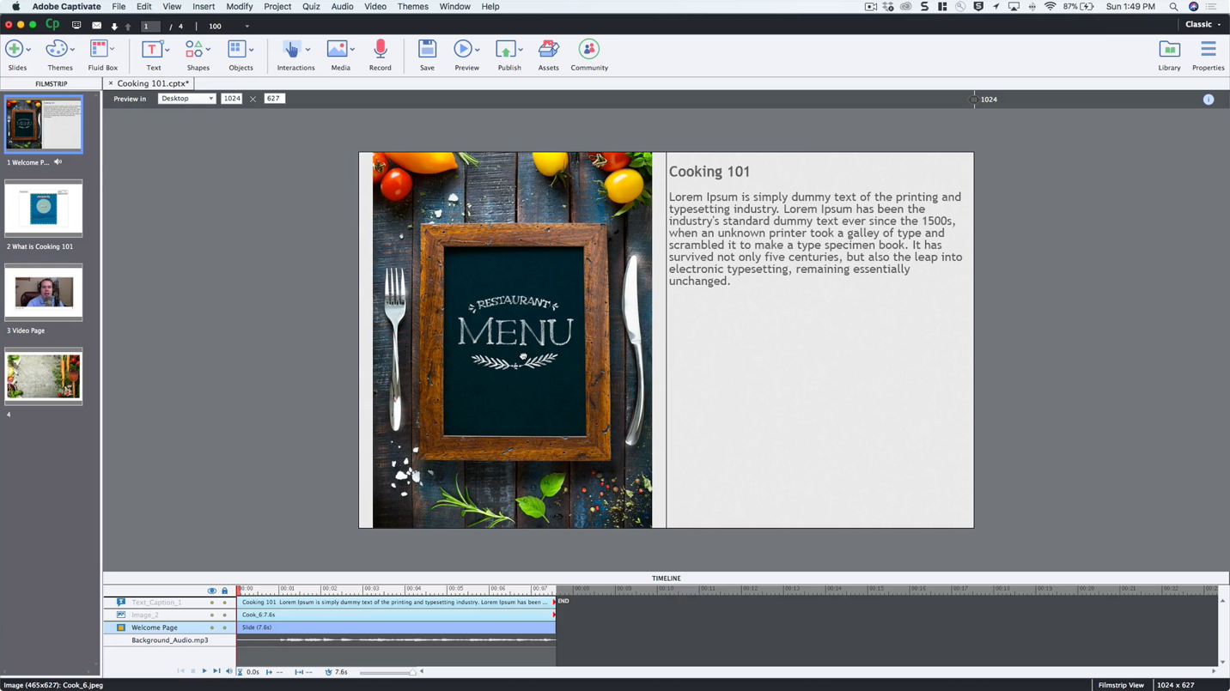

* Now we need to add the animation so click on properties and then click into the timing tab and select an animation you want to apply.

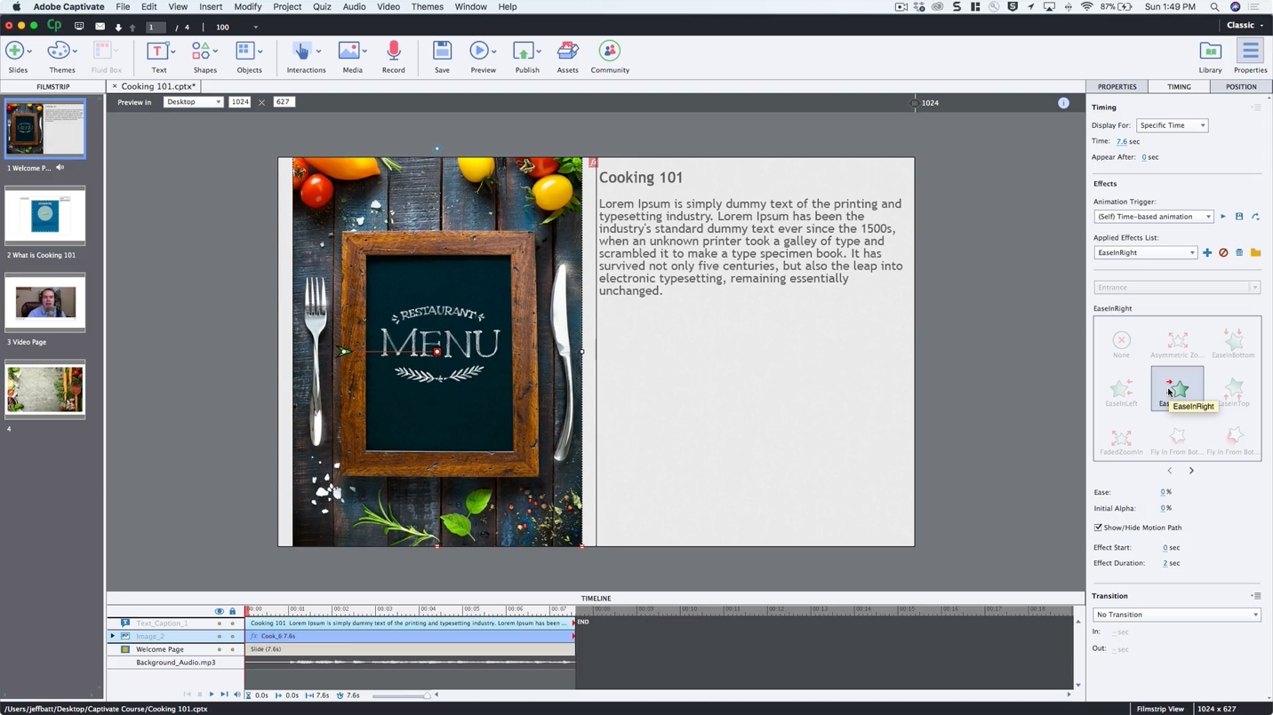

* With the animation applied, in the timeline you can twirl down to see the animation and you can adjust the timing of the animation by clicking and dragging out the desired length of the animation.

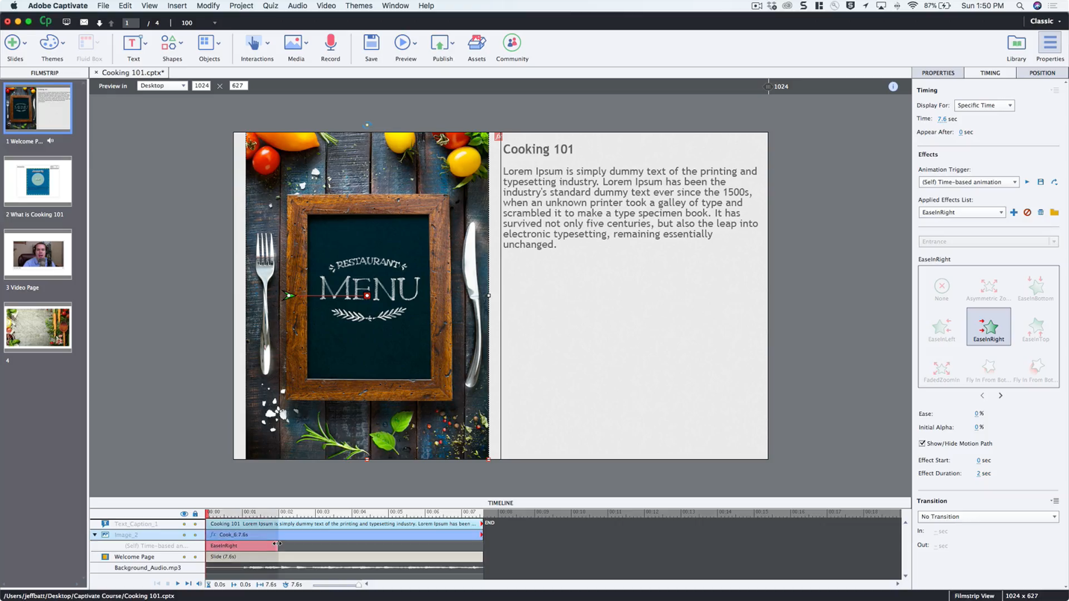

* Now we are going to animate the text on the right-hand side. With the text selected add a similar animation to the text on the right-hand side.

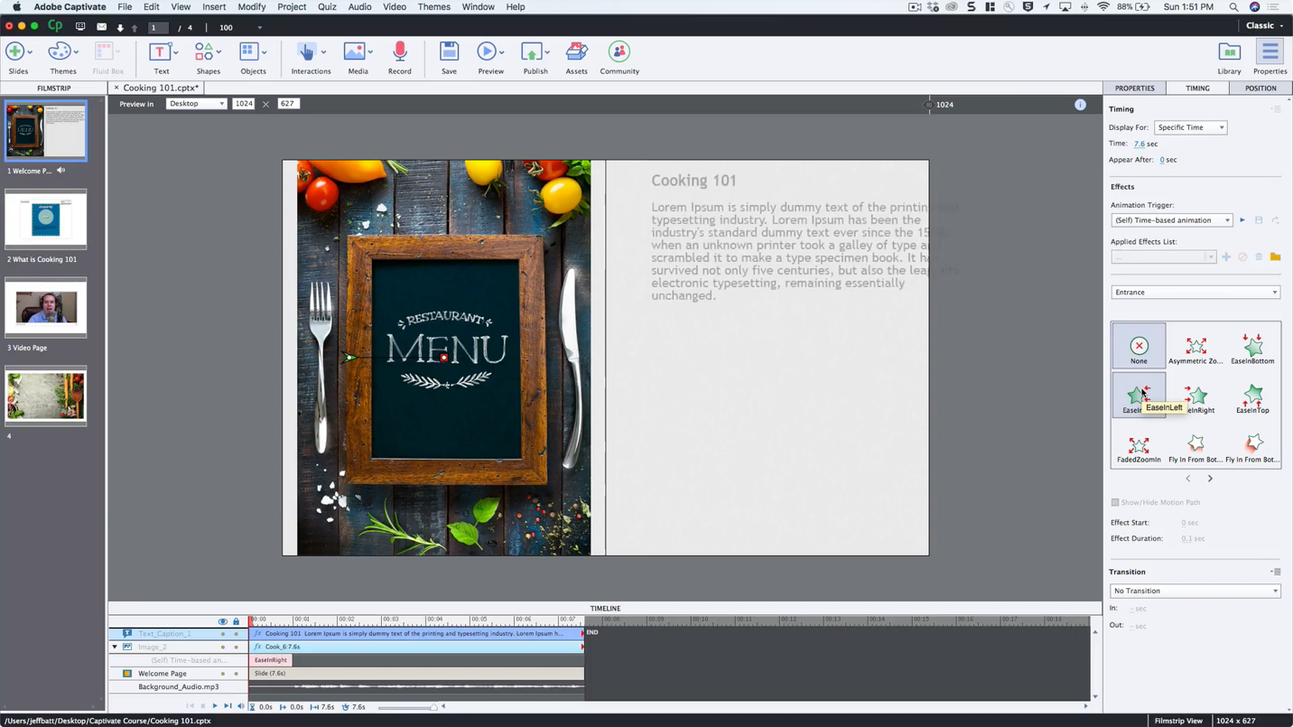

* Twirl down to see the animation on the text and adjust it so the animation happens right after the animation.

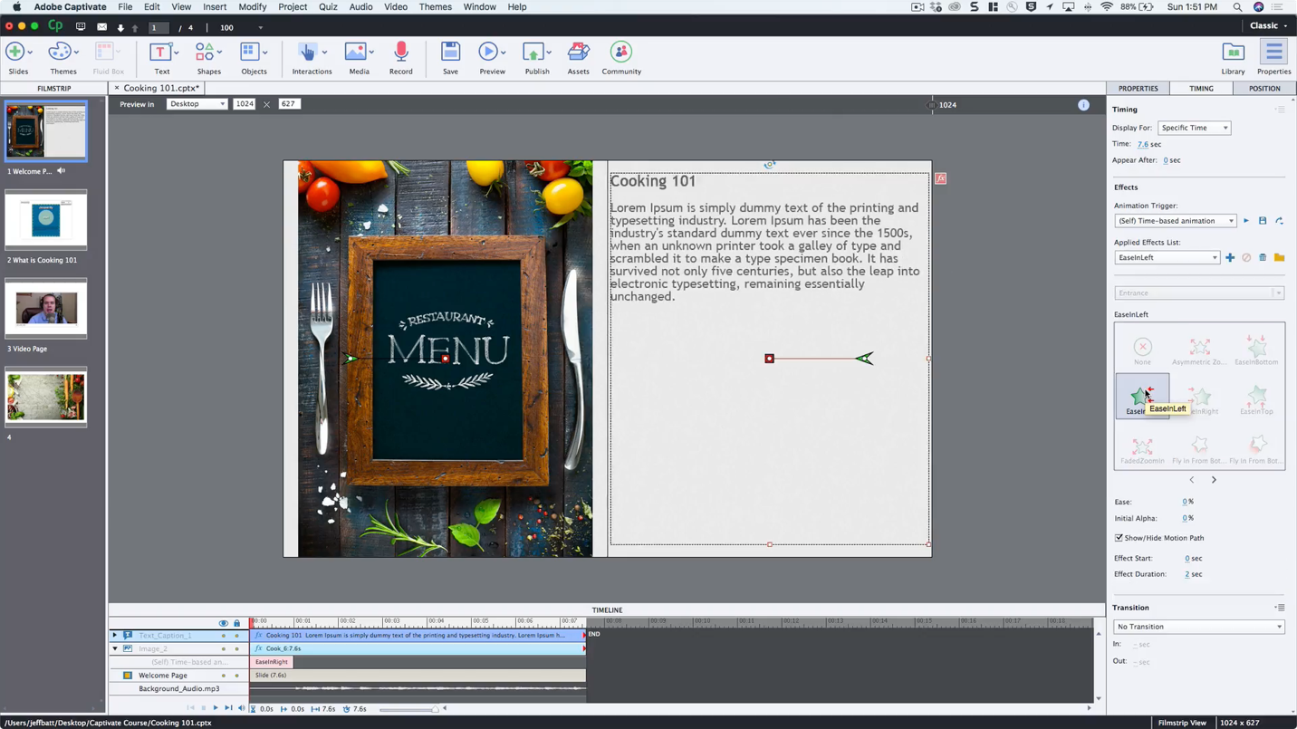

* The animation does not start from off the stage so let’s drag the green arrow of the animation off the stage.

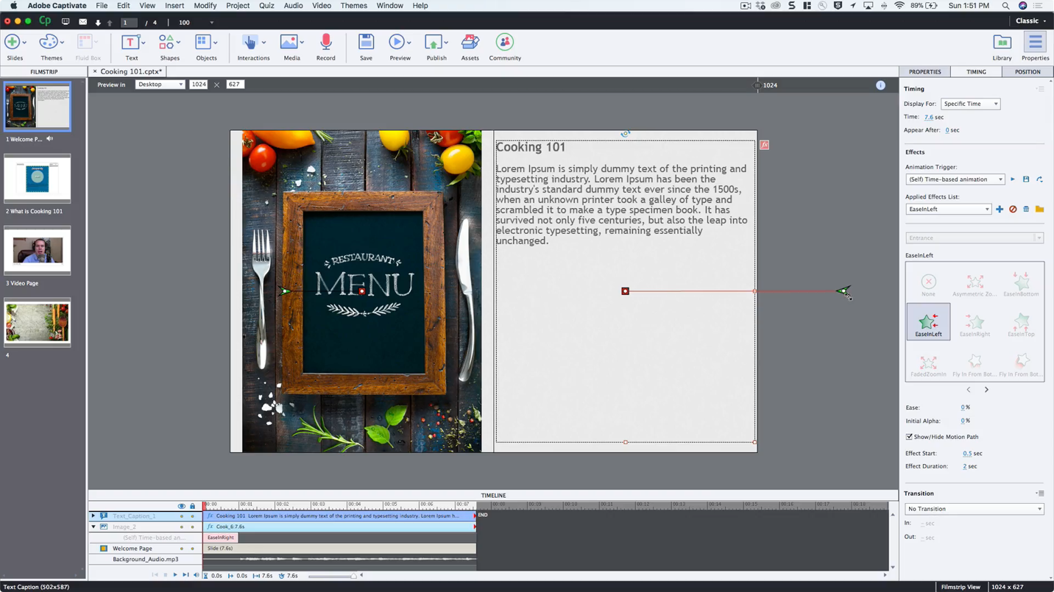

* Now we are going to add an animation to the video. Go to slide 3 and add on a zoom in animation to the video.

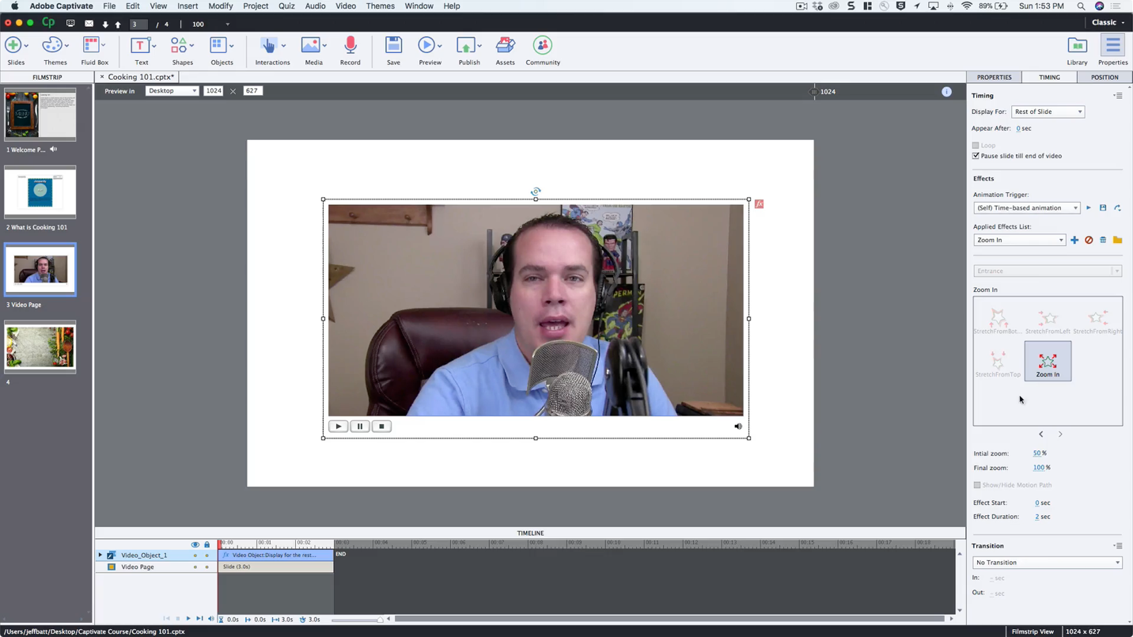

* Let’s make this animation a little subtler. With the image selected go into the timing section and in the initial zoom part change it to

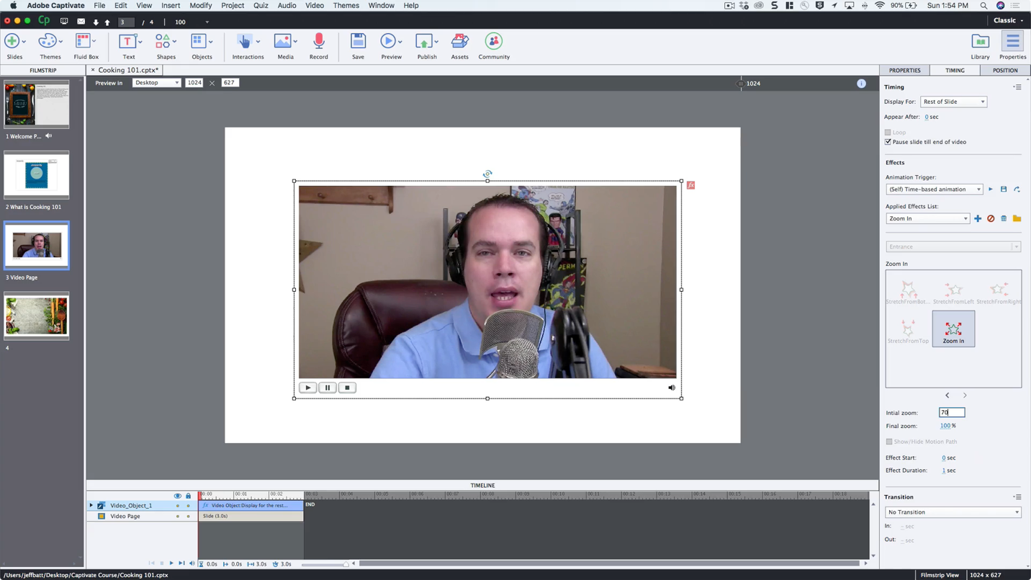

* Preview the page to make sure the animation looks good now.

**Section 6**

* Pull open your Cooking 101 course. We are going to add some quiz questions into this course.
* Make sure you select the late page to make sure the quiz questions insert after that page. Click the Slides menu item then click “Question Slide”

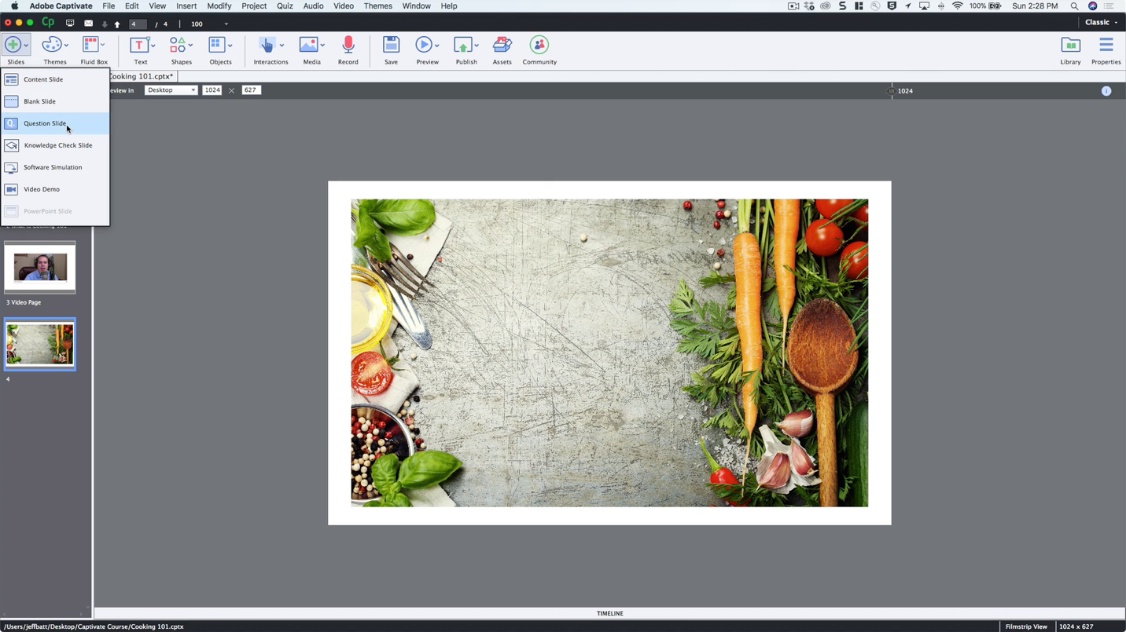

* In the pop-up box, click the Multiple Choice option to insert 1 multiple choice quiz question. Make sure the graded option is selected and press ok.

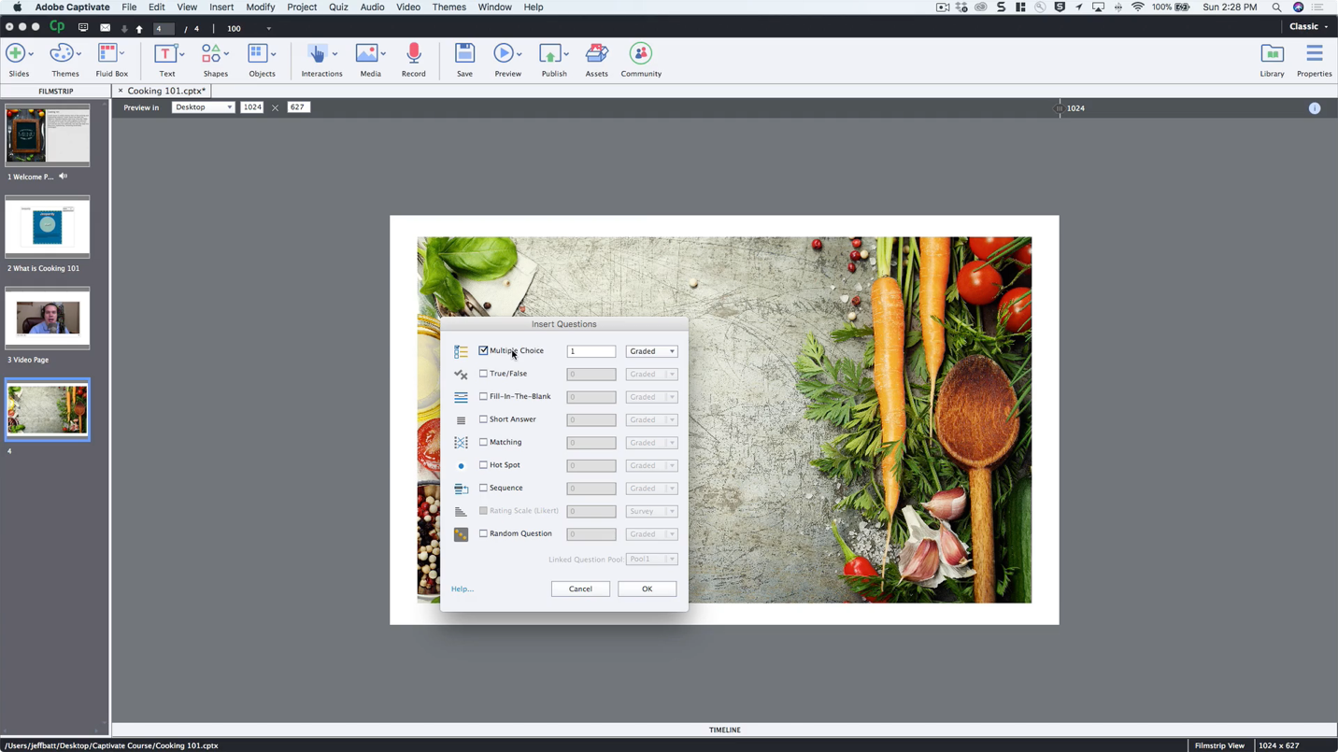

* With the question added. You can start to replace the current text with your own text and even hit enter after the last choice to type in more possible choices.

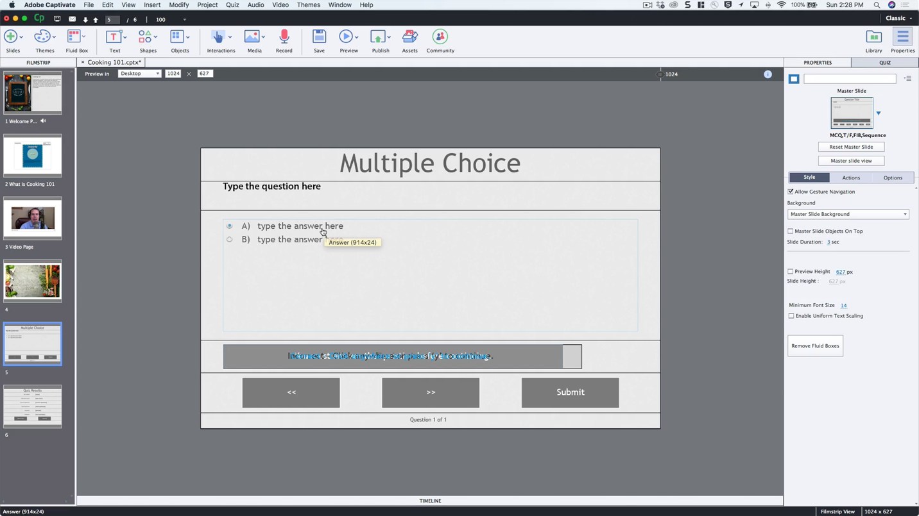

* With the quiz page selected you can go into the quiz tab within the properties tab to adjust some of the quiz settings.

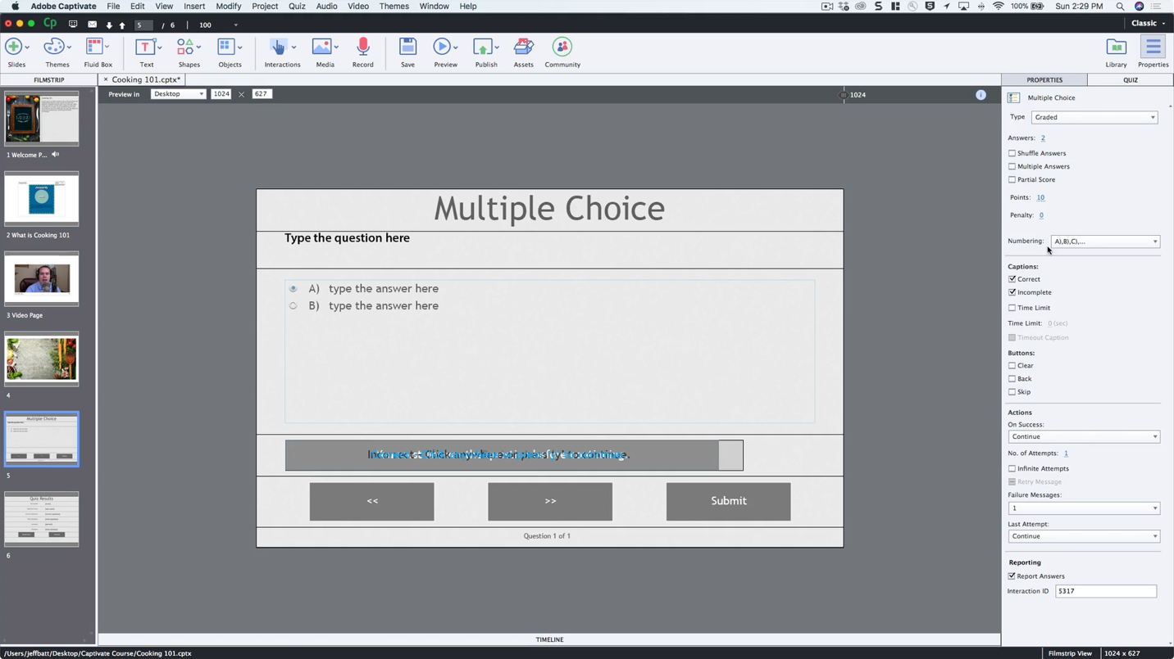

* To finish up this lab. Insert 4 more total quiz questions and adjust the text for each quiz question.

**Section 7**

* Open up the Cooking 101 course. We are going to adjust some of the content in other pages to use fluid boxes or anchor points.
* Go into page 2 and click on the properties button on the top right.

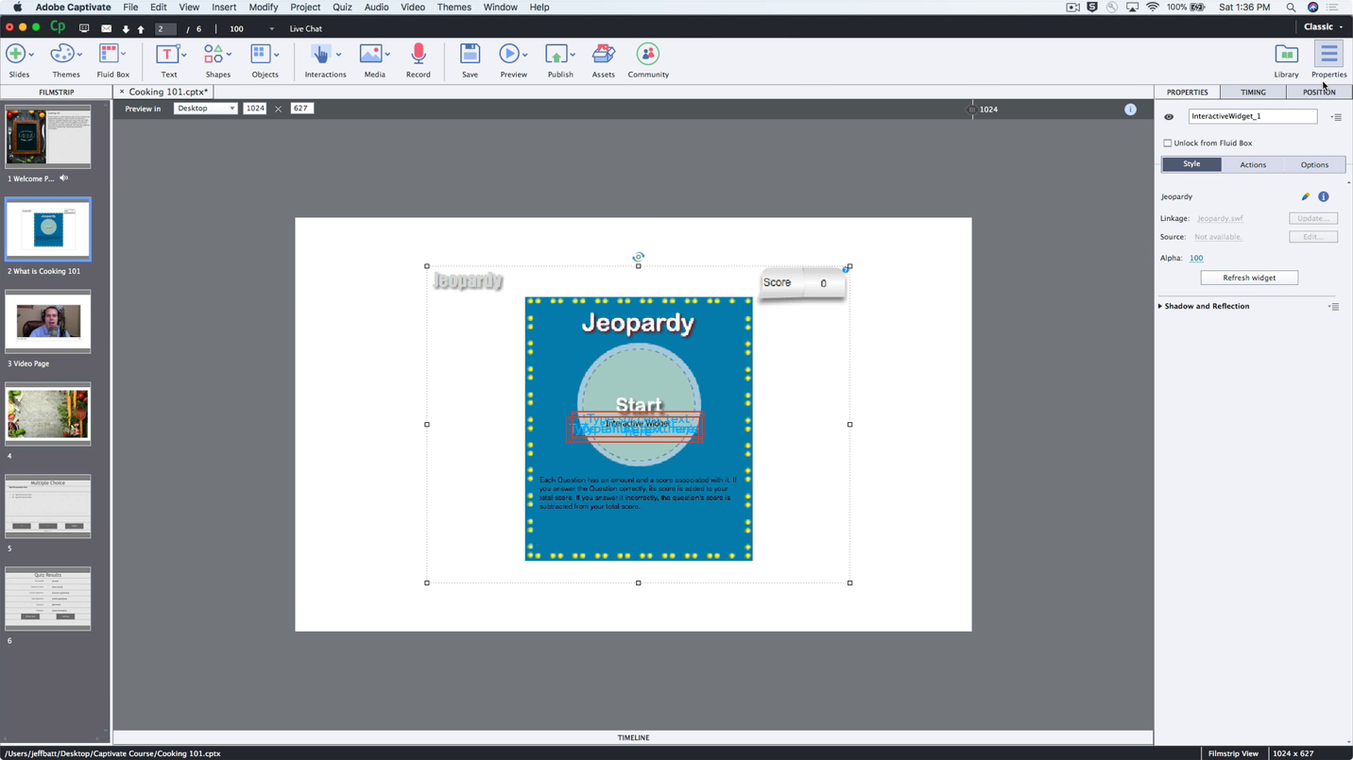

* Click on the position tab to show the position properties. Click on smart position to see the anchors that will anchor this to the top and left.

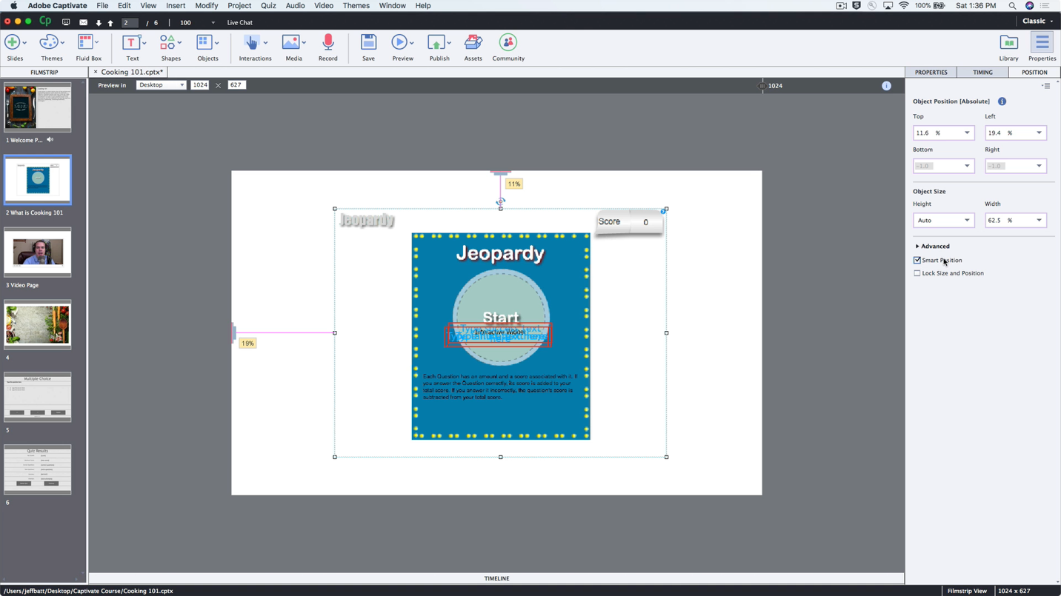

* Go to other pages in the course and see what other pages you can split up into fluid boxes.
* To have text adjust size you can click on the option “Enable Uniform Text Scaling”

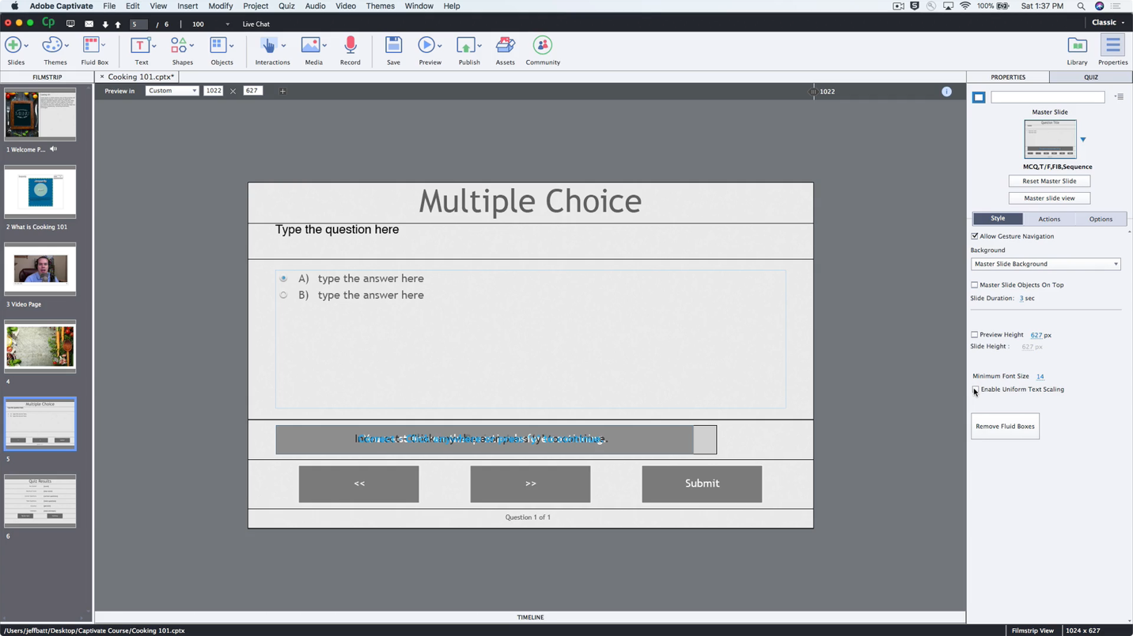

* Preview and make sure your content works great on all screen sizes

**Section 8**

* Open up your Cooking 101 course.
* Select page 4. We are going to insert a blank page after page 4. Click on Slides > Blank Page

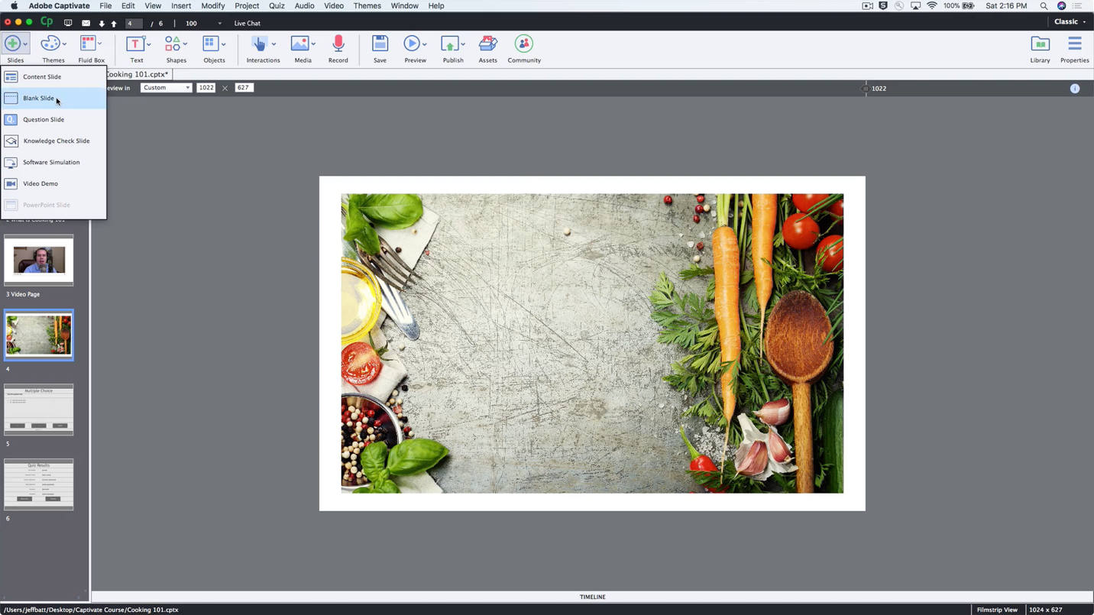

* Within the new page, we are going to create two horizontal fluid boxes. Click the Fluid Box and select two columns.

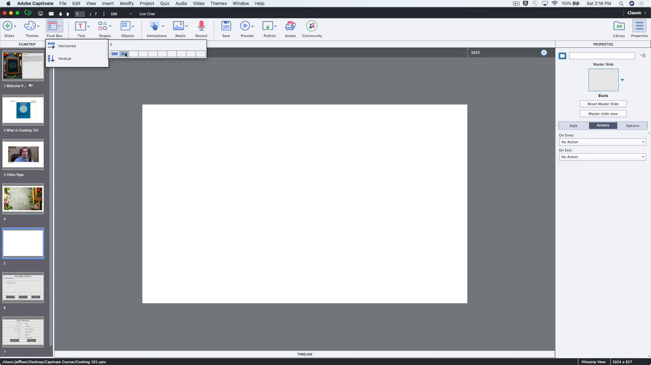

* Adjust the left column to be smaller than the box on the right-hand side

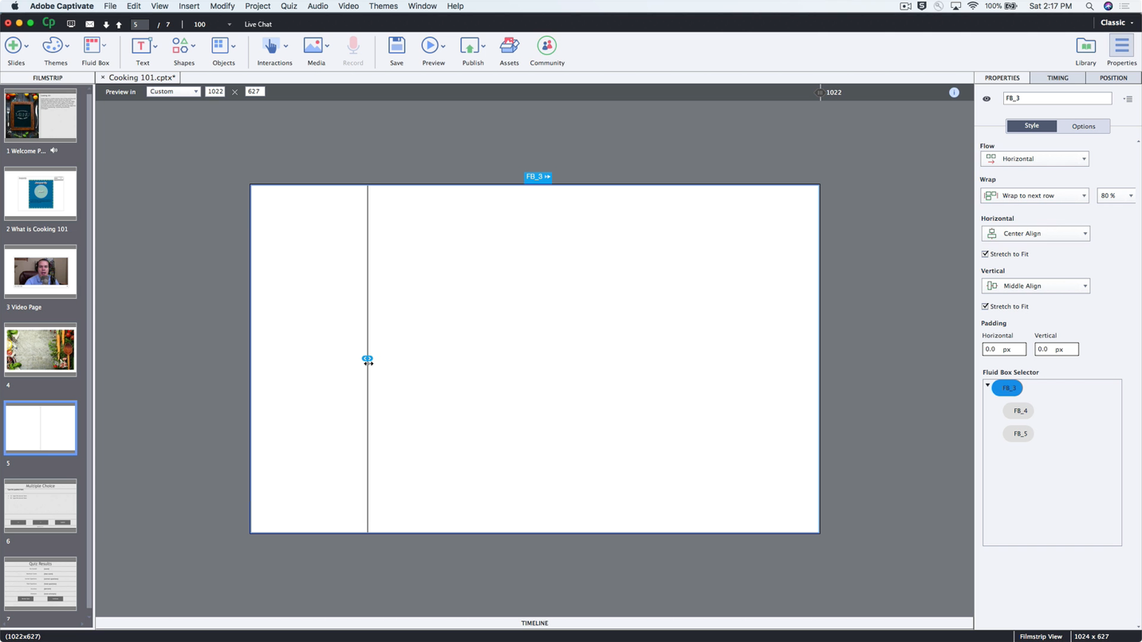

* In the right column we are going to insert an image and text to show content.
* Insert the image and align image to top. Also add some padding within that fluid box.

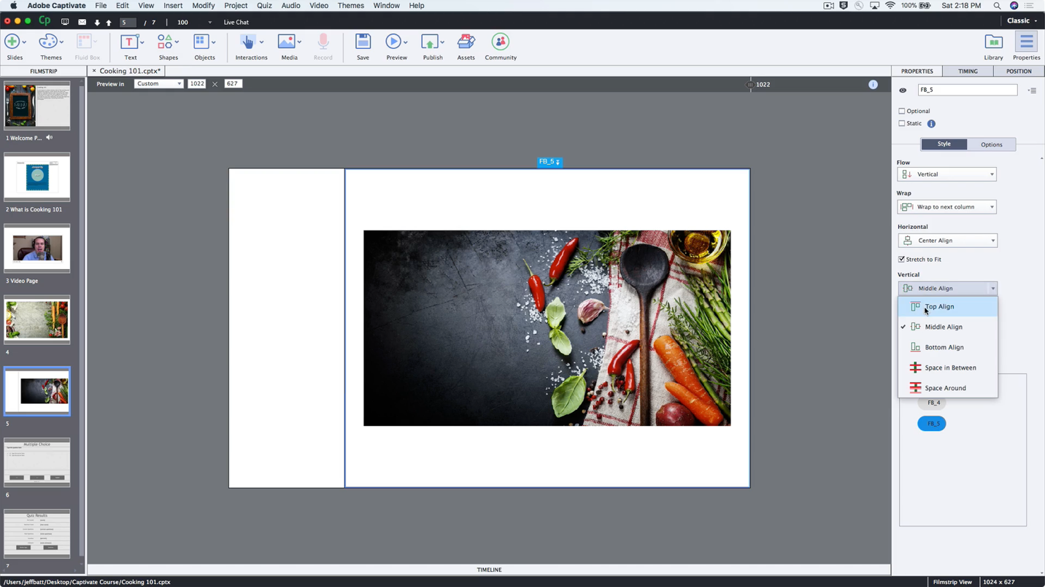

* Click below the image and insert text under the image. This will insert right below the image.

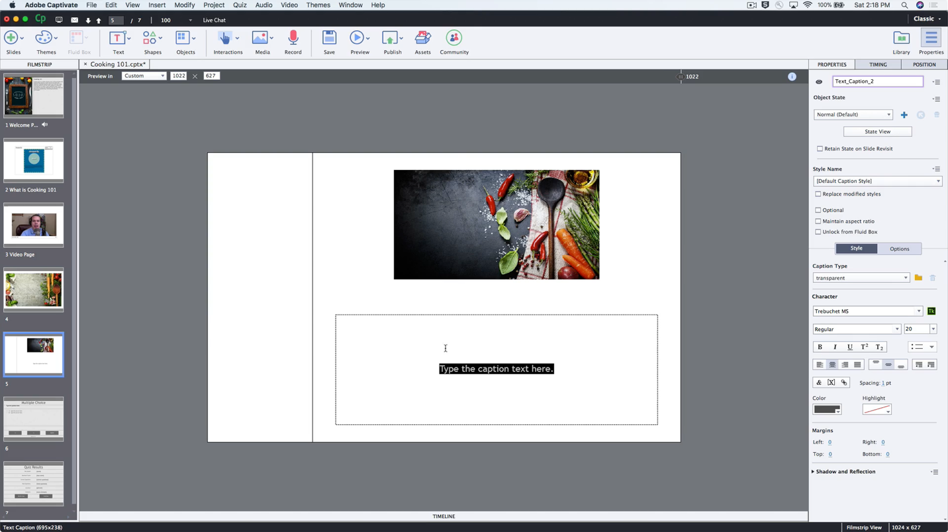

* Align the text left and to the top and replace the text.

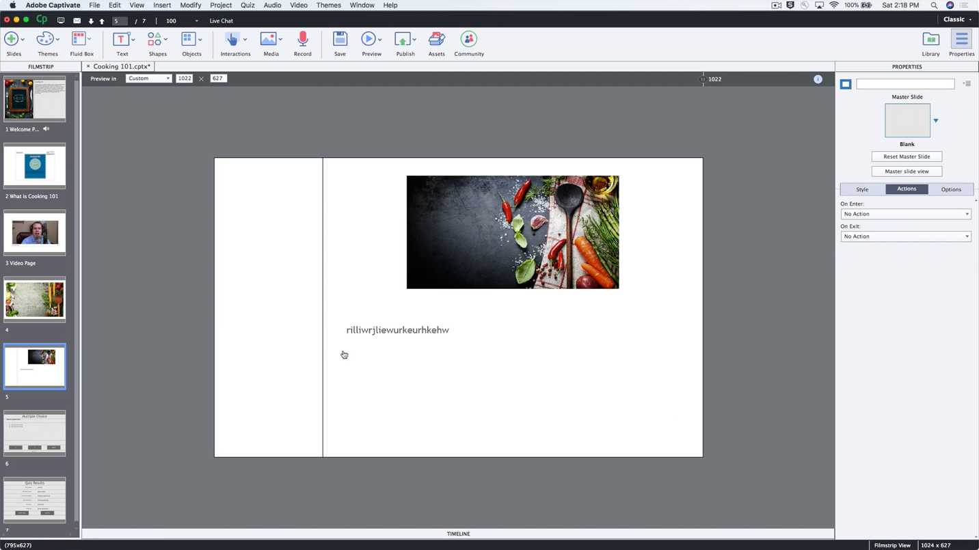

* We can now create three shapes that will be tabs that will trigger a change state for the image.

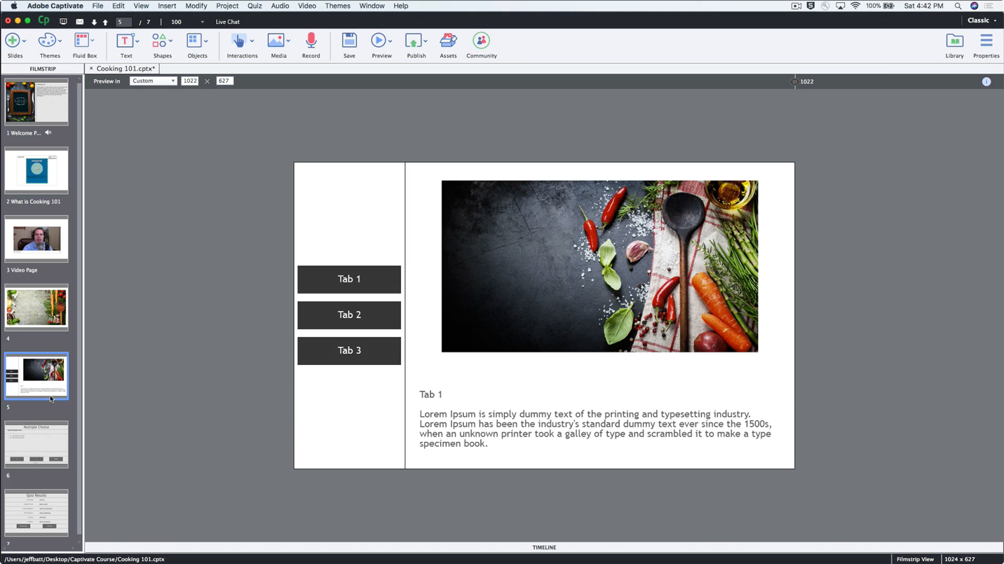

* Click your image and create various states of the image. Then add the trigger to change the state, depending on which tab was selected.

**Section 9**

* Open up Cooking 101. Go to the tab interaction. We want to prevent the user from clicking next before they have visited all 3 tabs.
* We will want to hide playbar when they come to the page, so they cannot just use the next button to go onto the next page. Under the action settings on the page properties make sure in On Enter you have selected “Hide Playebar”

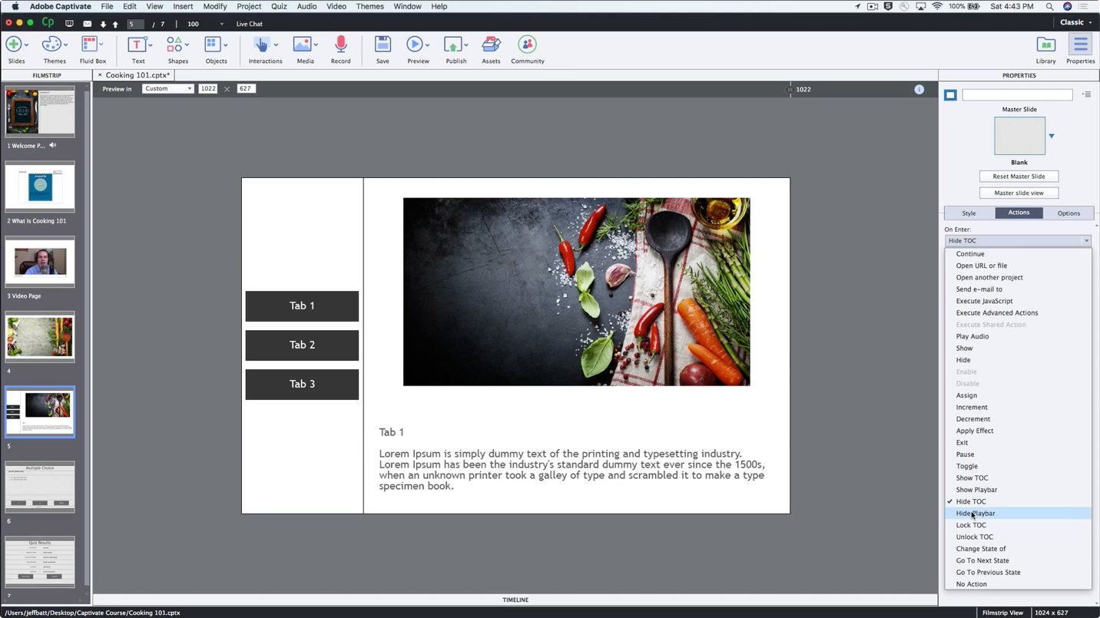

* We do have to have a continue button since we no longer have a playbar. create a shape that will be our continue button. Create a shape and add the text “Continue”

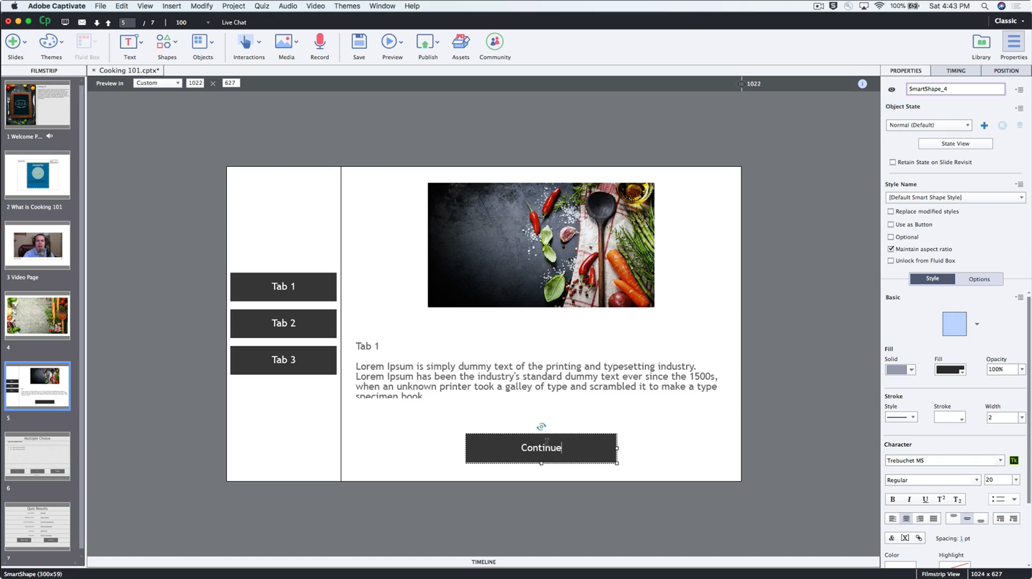

* Let’s align the tabs to the top so select the fluid box and select the option to align the tabs to the top of the fluid box.

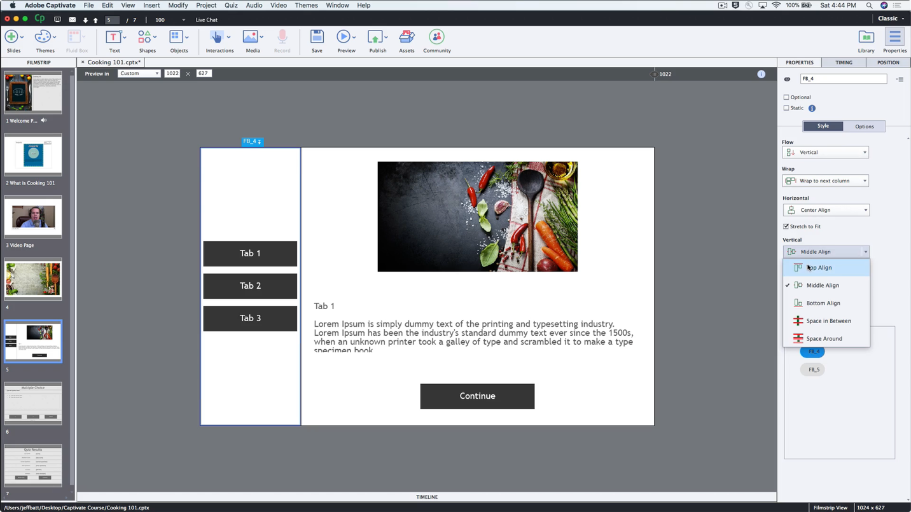

* We will need a prompt to let the user know they have to visit all 3 tabs. Insert a text caption below the tabs instructing the user to click on each tab

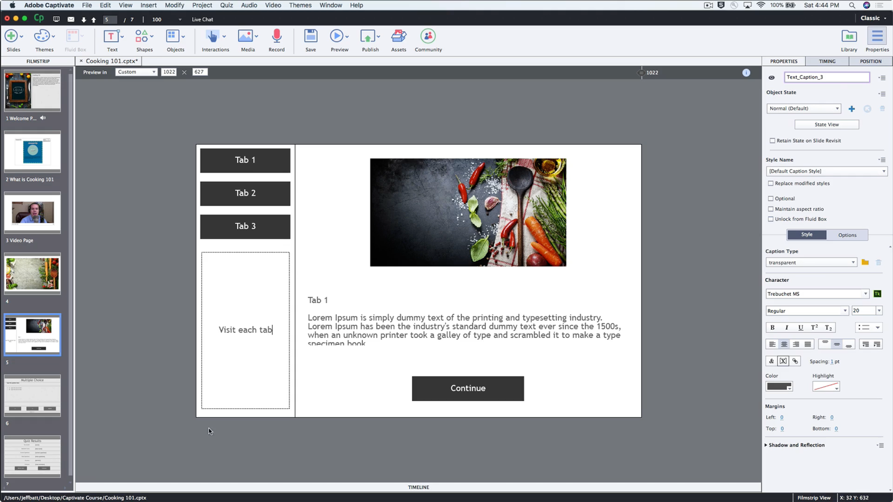

* We do not need this showing at first so go into the properties and toggle the eyeball to not be shown by default.

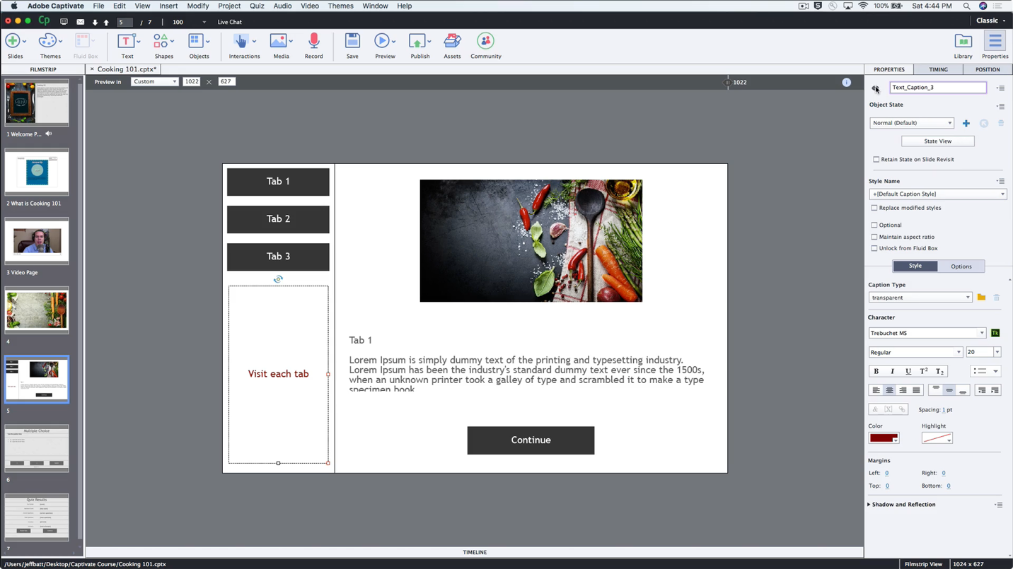

* We need to create variables that will keep track if each tab is visited. Go into variables.

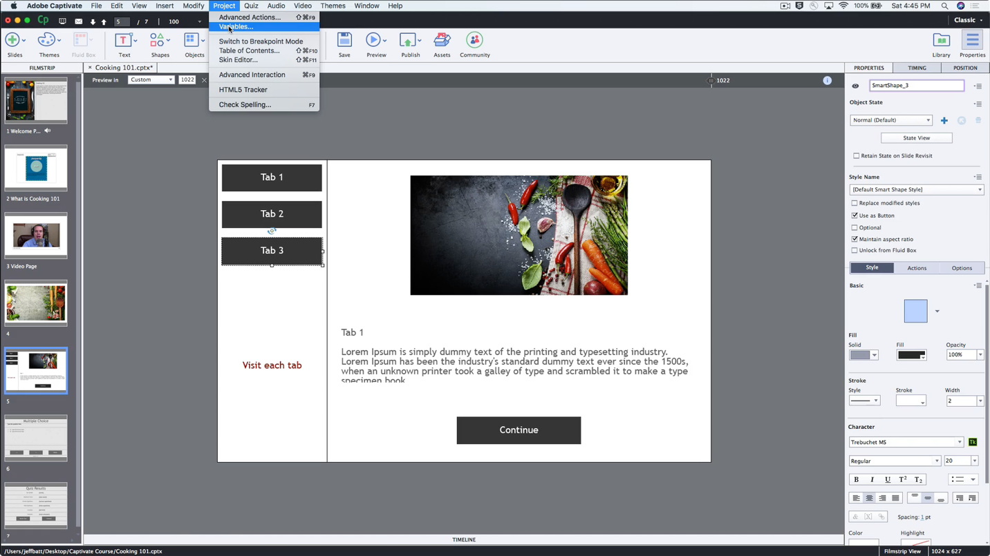

* Create 3 user variables named tab1, tab2 and tab3. All will have the default value of 0.

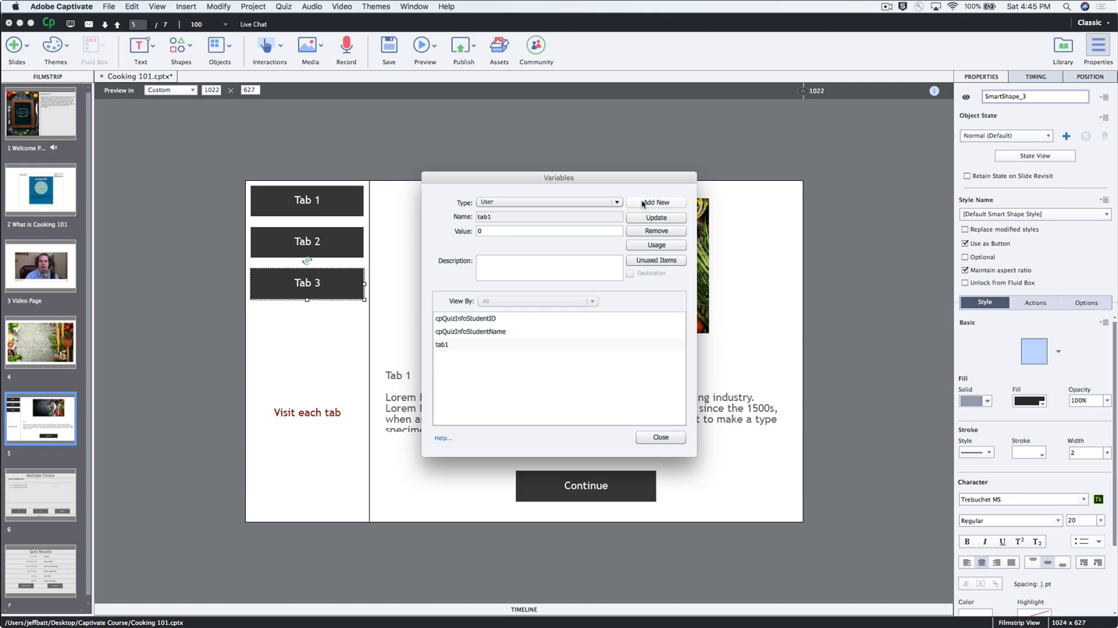

* Let’s add the trigger to increase the tab1 variable. Since we will need to also have it do other things we will need to create an advanced action. With tab 1 selected click actions click on “Execute Advanced Action”

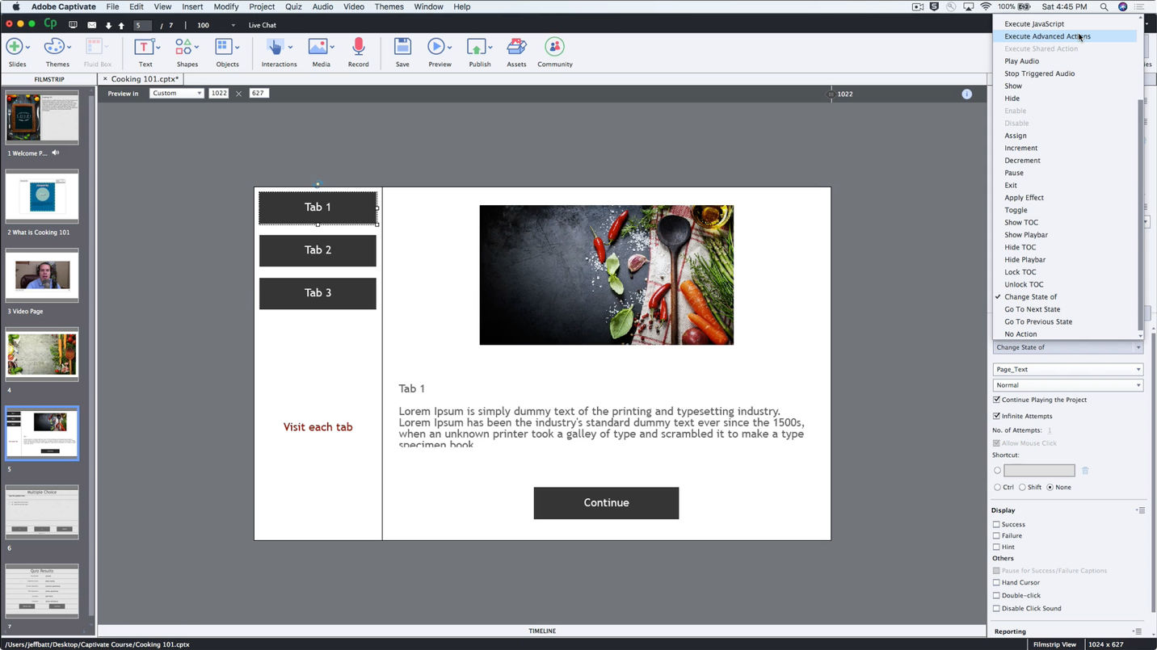

* Click on the folder icon to create a new advanced action.

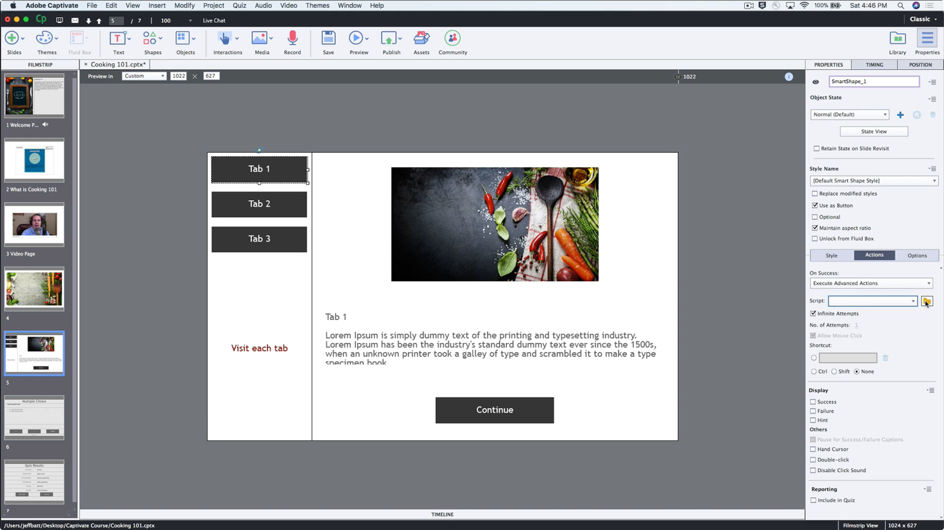

* Create the advanced action from a blank advanced action and call to switch_tab_1

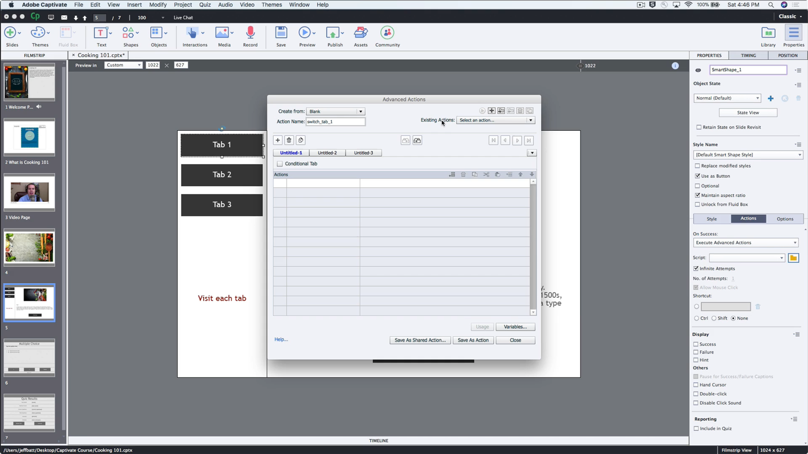

* In the action first change the state of page text to be normal.

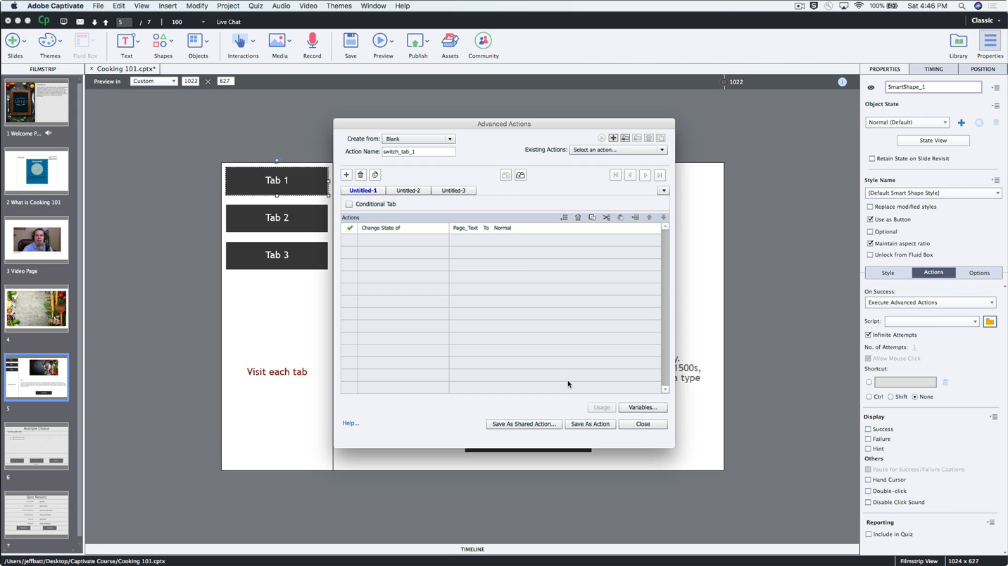

* Next you will need to assign the tab1 variable to be the value of 1. Then click “Save Action”

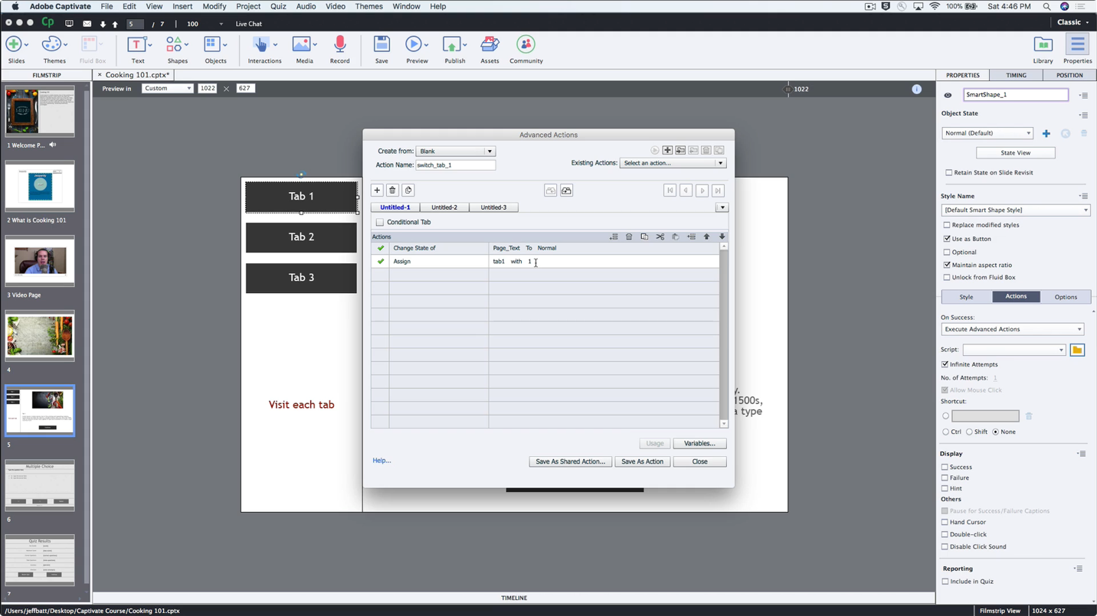

* Create another advanced action by clicking on blank and then call it switch_tab_2

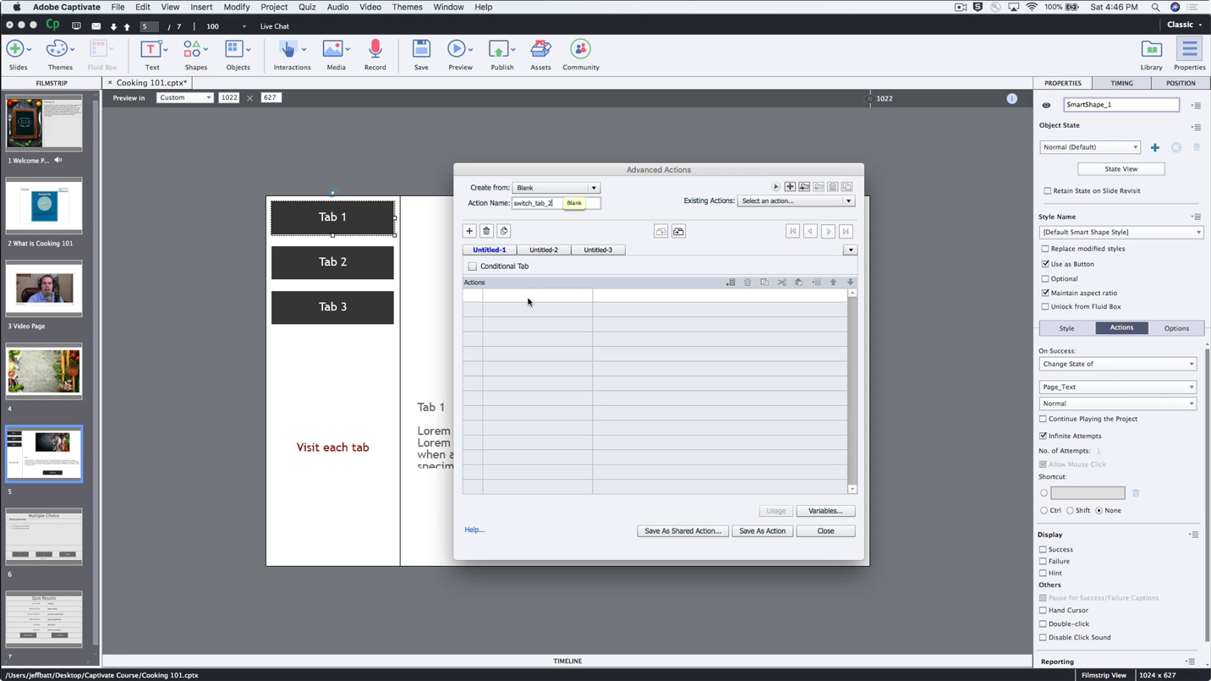

* Create the two action first switch the page text to be the state of 2. Assign the variable of tab2 to be the value of 1

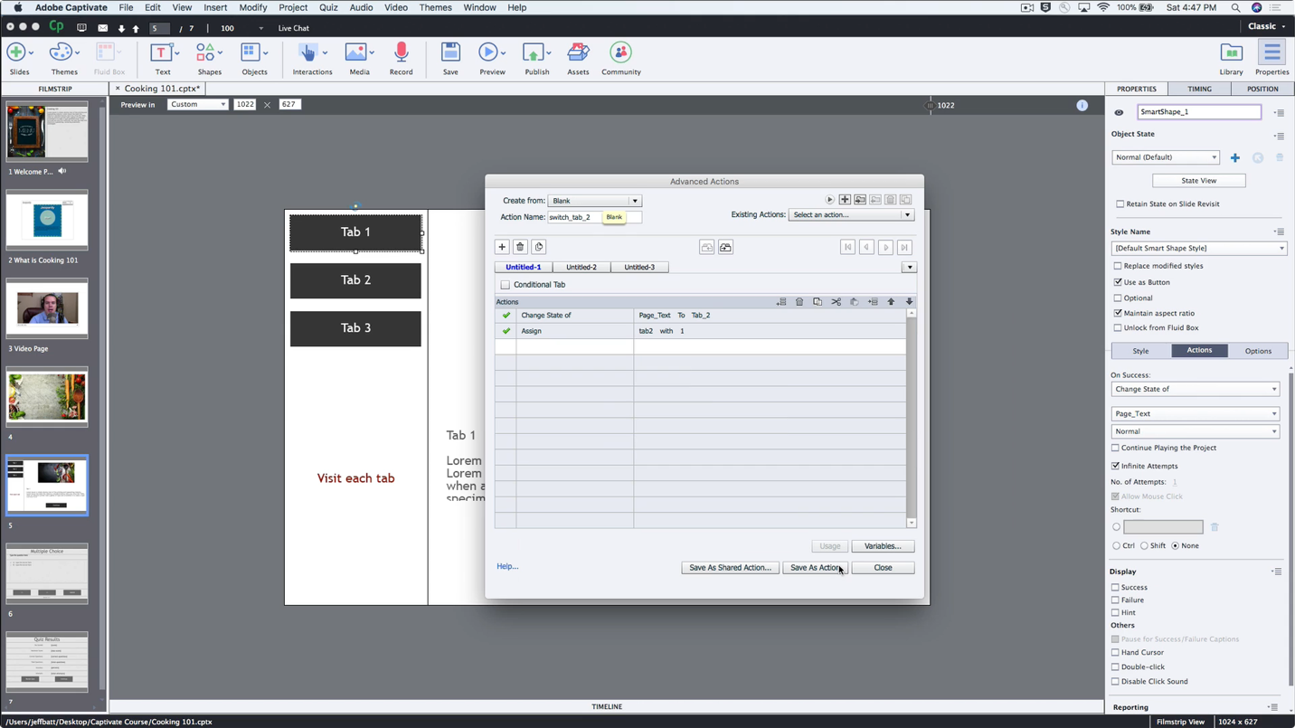

* No will create one more action. Call the action switch_tab_3. Then switch the page text to be the state of 2 and assign the variable of tab3 to be the value of 1.

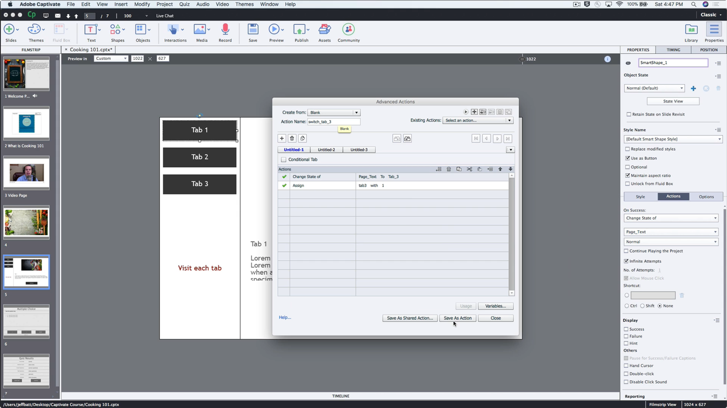

* Click save action and close your advanced actions.

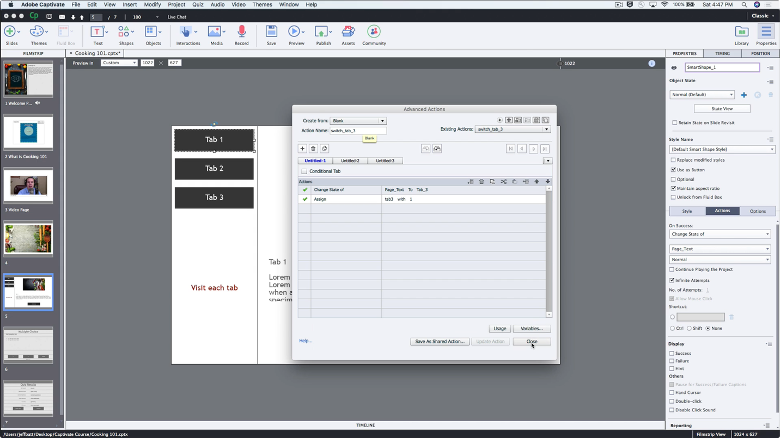

* Click on tab and make sure it executes the adv action to switch_to_tab1 and then do the same thing for tab2 and tab3

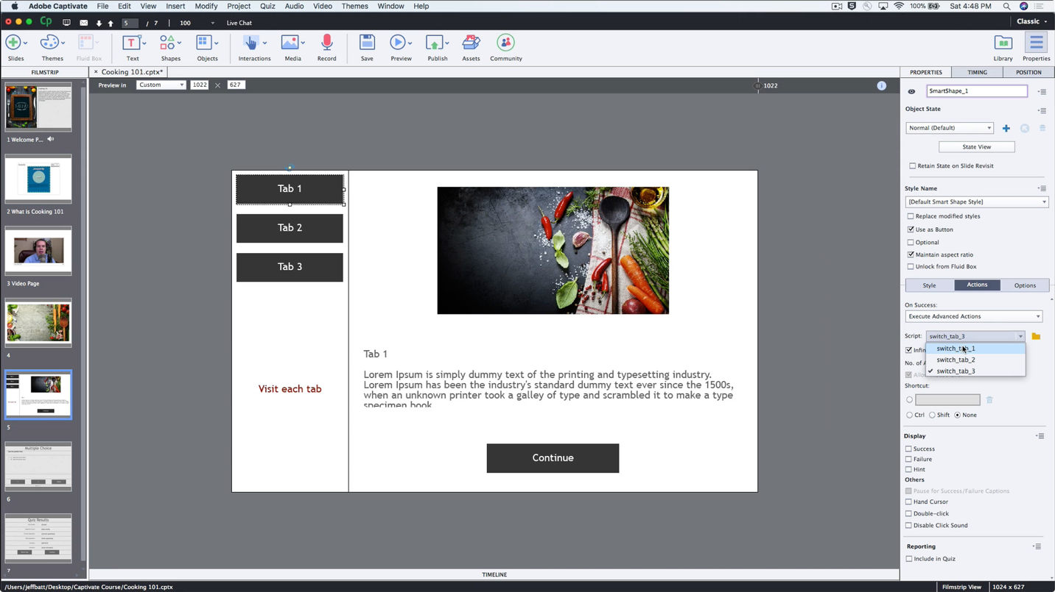

* Go back into the advanced actions section and create another advanced action for the continue button.

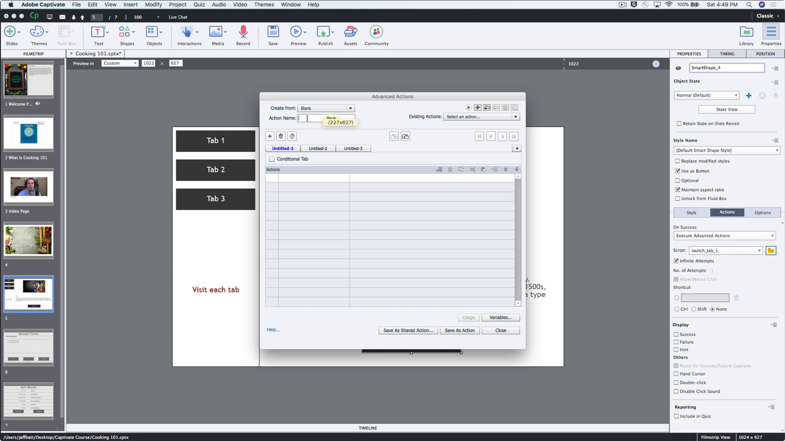

* Call this action will be called continue.

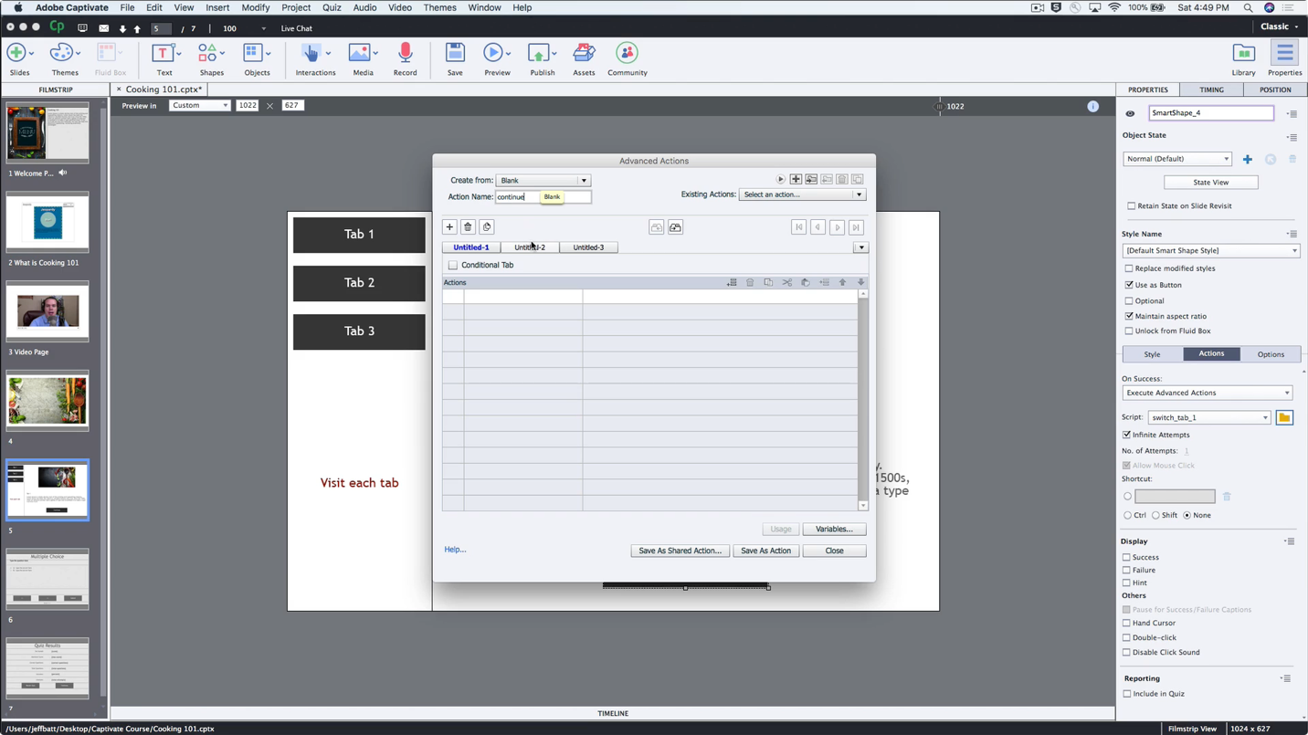

* Make sure that you click the conditional check box so that this action can be an action.

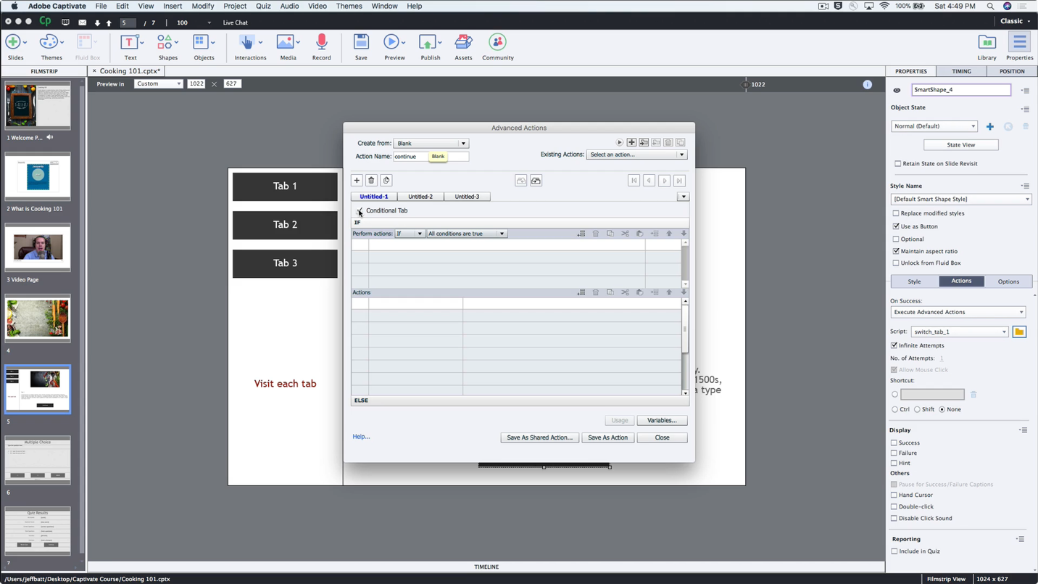

* In the conditions create the condition If tab1 is equal to 1 and tab2 is equal to 1 and tab3 is equal to 1 then we run the code that will jump to the next page.

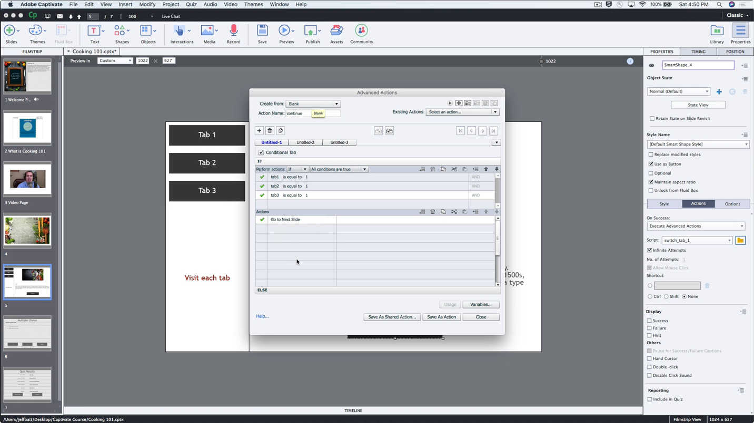

* If it is not true (Which goes in the else section), then we will show the text_caption that says they need to finish.

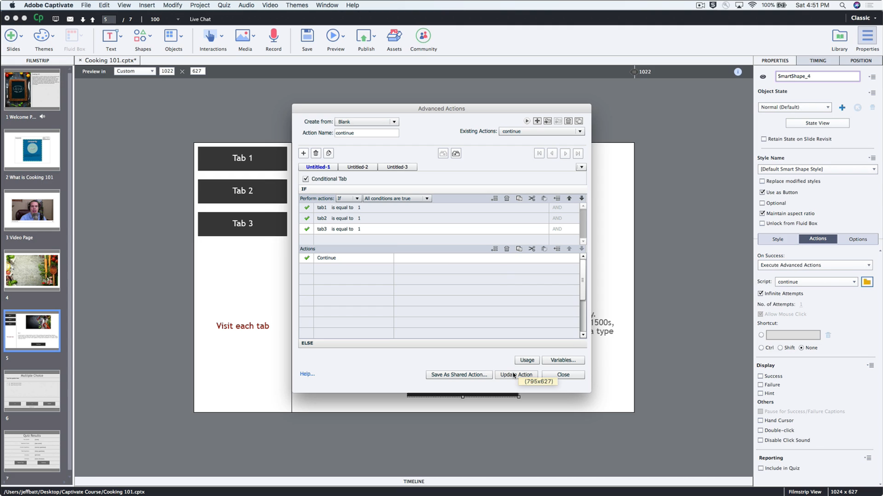

**Section 10**

* Open up the Cooking 101 course.
* Click on publish for devices

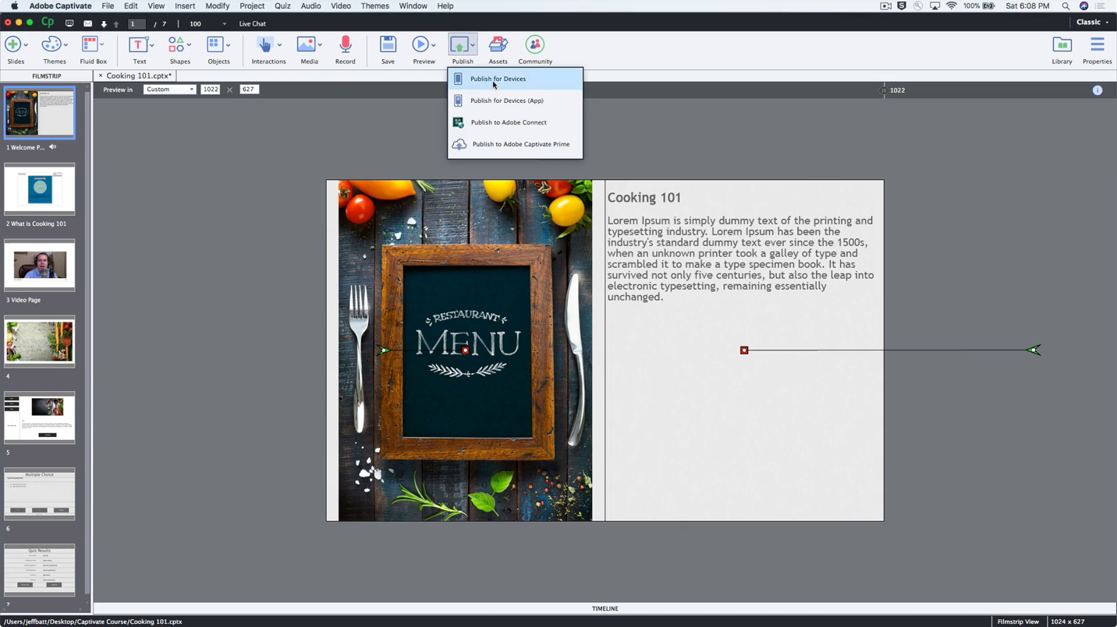

* Click on the eLearning Output link to enable SCORM.

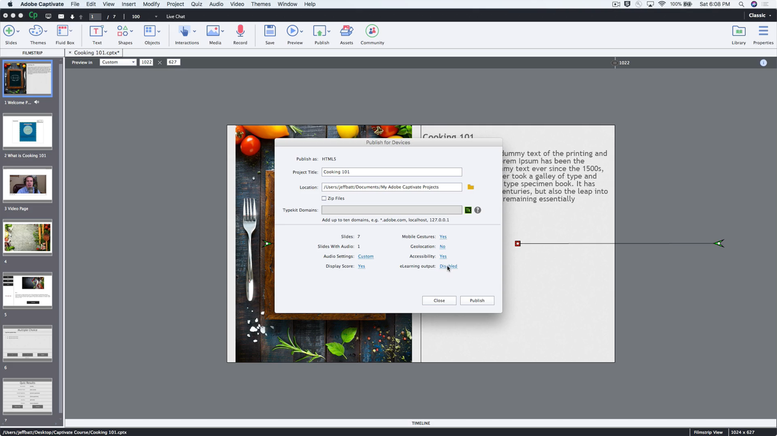

* Click “Enable reporting for this project” and change the standard to SCORM 2004.

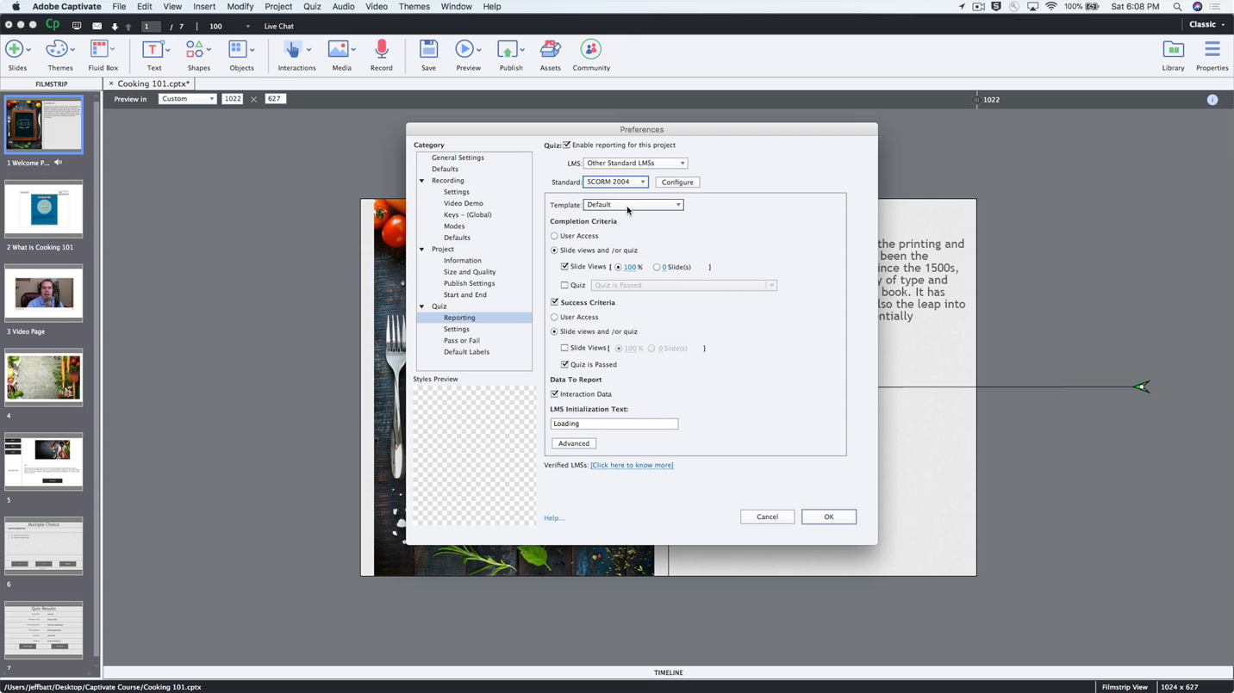

* Set completion backed on slide views. Change the percentage to 90% and then click ok.

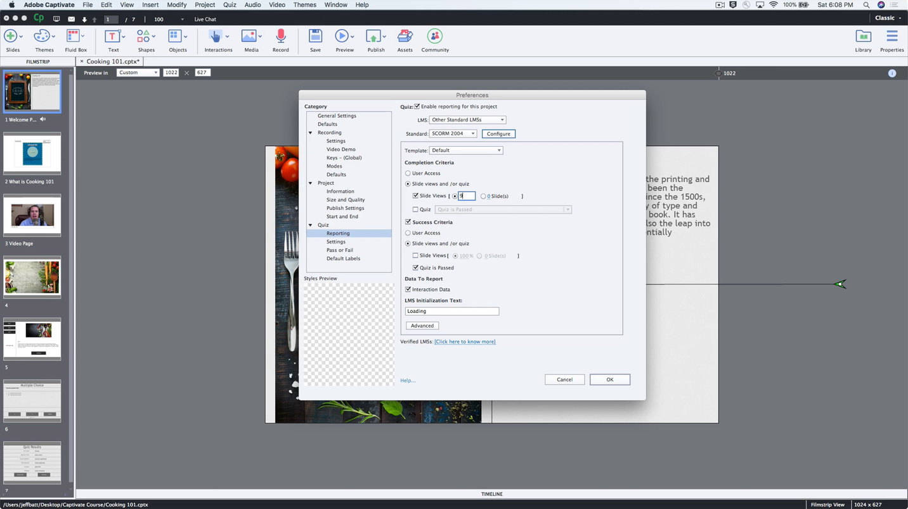

* Click on Publish button.

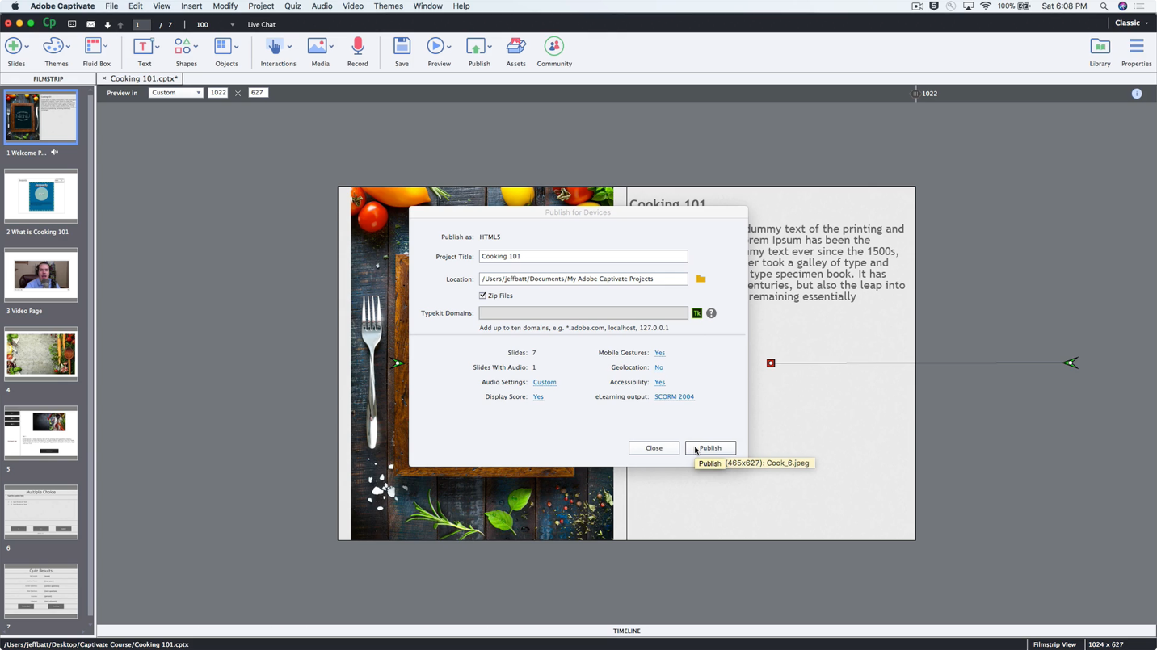

* Upload your course to SCORM cloud to test completion